**Question 1**

1.1 C

1.2 B

1.3 D

1.4 A

1.5 A

1.6 B

1.7 D

1.8 C

1.9 A

1.10 A

**Question 2**

2.1.1 acceleration is rate of change of velocity. (2)

* + 1. 9,8 m.s-2✓ down✓ (-9,8 m.s-2 down: only 1 mark) (2)
    2. vf = vi+ gΔt✓ (implied formula will get this mark)

0 = 15 +(-9,8). Δt✓(subst) (2)

Δt = 1,53 s

* + 1. Δx = viΔt + ½ gΔt2

=15(1,53) ✓ + ½ (-9,8)(1,53)2 ✓ up is +

= 11,47 m✓ (3)

OR Option 2:

Area under the v/t graph = ∆x

Area of a triangle = 1 b h = 1

× 1.53 × 15 = 11,48 m

2 2

∆x = 11,48 m

* + 1. vf2 = vi2 +2gΔx

(-34)2 ✓ = 152 + 2(-9,8)Δx ✓✓(sign correctly substituted)

Δx = -47,5 m (magnitude hence disregard sign) (4)

* + 1. see Answer Sheet memo (3)
    2. see Answer Sheet memo (3)

2.1.8 t = 2,2 s (1)

* + 1. A is above B (1)
    2. displacement is given by area under graph.

Area UNDER AXIS (displacement down for B) > area Under X-axis (2)

for A.

* + 1. Take down as +

Ball A: Δx = viΔt + ½ gΔt2 Ball B : Δx = viΔt + ½ **a**✓Δt2

Δx = -15 Δt + ½(9,8)Δt2 ….✓ (1) Δx = 1,5 Δt2…..✓ (2)

Subst 2 into 1: (method) ✓

1,5 Δt2 = -15Δt +4,9 Δt2

3,4 Δt2 – 15Δt = 0

Δt (3,4Δt – 15) = 0

Δt = 4,41 s✓ (5)

* + 1. see Answer Sheet memo (5)
  1. 2.2.1 speed is rate of change✓ of distance✓ (2)
     1. speed = distance/time = 400✓ /105✓ = 3,8 m.s-1✓ (3)
     2. 3,8 m.s-1✓ west✓ (2)

**[40]**

**Question 3**

3.1.1 Fh = 200 cos 30o = 173,21 N✓ right ✓

Fv = 200 sin 30o = 100 N ✓down✓ (4)

3.1.2 The perpendicular force✓ exerted by a surface on an object is in contact

with it. ✓ (2)

3.1.3 FN = mg + Fv  ✓ (or implied)

= 40(9,8) ✓ + 100 (COE from 3.1.1)

= 492 N✓ (3)

3.1.4 Force that opposes the motion of an object✓ and acts parallel to the

surface with which the object is in contact. ✓ (2)

3.1.5 Ffs (max) = μsFN ✓

= 0,4 (492) ✓ (COE from 3.1.3)

= 196,8 N✓ (3)

3.1.6 Her foot will not slip because Fh < Ffs(max) (2)

3.2.1 Fnet = FT – Ff (on child skateboard) (or implied)

Fnet = ma ✓

55(2) ✓ = Ft – 80✓

Ft = 190 N✓ (4)

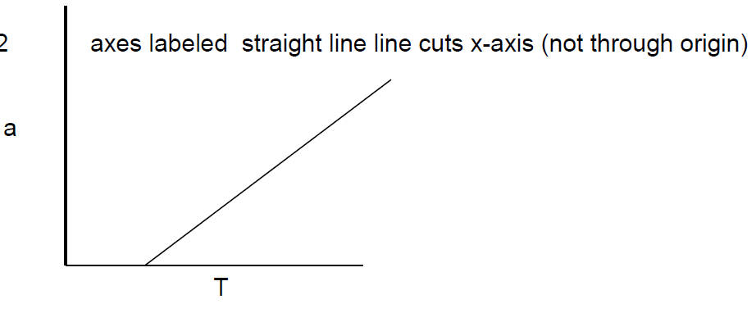3.2.2 (3)

3.2.3 (The child continues to move forward when the T is removed) and also continues to move forward when the board strikes the stone✓ as the child

does not ✓ experience a net force. ✓ (3)

3.2.4 Newton’s first law. (1)

**[27]**

**Question 4**

4.1.1 The total (linear) momentum✓ of an isolated system remains

constant✓ (is conserved). (2)

4.1.2 (*Ptotal)before* = (*Ptotal*)*after*✓

(0,005)(200) + 0 = (0,195 + 0,005)v✓✓

v = 5 m.s-1 ✓ (4)

4.1.3 (EK + Ep)before = (EK + Ep)after✓

0,5(0,2)(5)2 + 0 = 0 + (0,2)(9,8)h✓✓

h = 1,28 m ✓ (4)

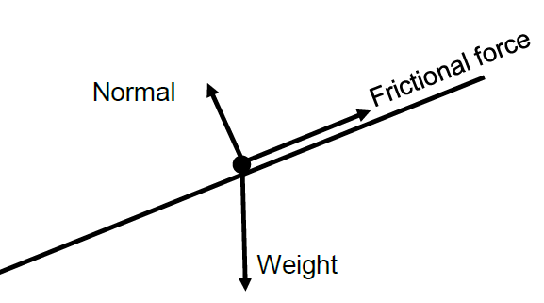4.2.1 (4)

3 forces✓✓✓

slope✓

4.2.2 Normal force. (1)

4.2.3 EK = 0,5mv2 ✓

= 0,5(70)(4)2 ✓

= 560 J ✓ (3)

4.2.4 Fnet = mg sin20 – Ff✓

= (70)(9,8)sin20 – 190✓

= 234,63 – 190

= 44,63 N✓ (3)

4.2.5 The **work done by a net force**✓ on an object is **equal to the**

**change in the kinetic energy**✓ of the object. (2)

4.2.6 Fnet x s = ΔEK✓

(44,63)(18) = (EK)L – 560✓

(EK)L = 1363,34 J✓

0,5mv2 = 1363,34✓

0,5(70)v2 = 1363,34

V = 6,24 m.s-1✓ (5)

**[28]**

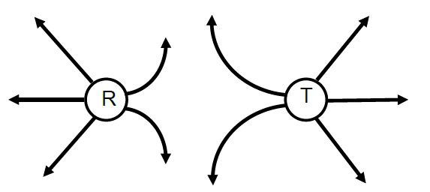**Question 5**

5.1.1

✓Direction

✓Shape

✓Zero point closer to R? OR perpendicular lines? (3)

5.1.2 q = 0,5(6nC +10nC) ✓

= 8nC✓ (2)

5.1.3 From R to T (1)

5.1.4 The force between two charges is **directly proportional to the product**

**of the charges**✓and **inversely proportional to the distance between**

**the charges squared**. ✓ (2)

5.1.5 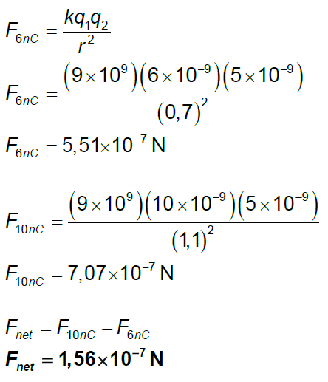

✓✓

✓✓

✓

✓ ` (6)

5.2.1 Every particle in the universe attracts every other particle with a force that is directly proportional to the product of their masses✓ and inversely proportional to the square of the distance between their centres. ✓ (2)

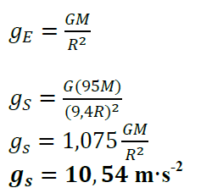

5.2.2

✓✓

✓

✓ (4)

**[20]**

**Question 6**

6.1.1 Potential difference is the work done✓ per unit positive charge. ✓ (2)

6.1.2 𝑉=IR ✓

3=6 𝐼 ✓

𝑰=𝟎,𝟓 A✓ (3)

6.1.3 𝑞=𝐼t✓

𝑞=(0,5)(10×60) ✓

𝒒=𝟑00**C**✓ (3)

6.2.1 emf is the total energy✓ per coulomb✓ of charge supplied by the cell. (2)

6.2.2 𝑉=𝑒mf−𝐼r✓

10=12−2𝑟✓

𝒓=𝟏 𝛀 ✓ (3)

6.2.3 𝑉=I𝑅 ✓

10=20 𝐼✓

𝑰=𝟎,𝟓 **A**✓(3)

6.2.4 𝐼 through 𝑅1=2,0−0,5=1,5 A ✓

𝑃=𝐼2 𝑅 ✓

5,85=(1,5)2 𝑅1 ✓

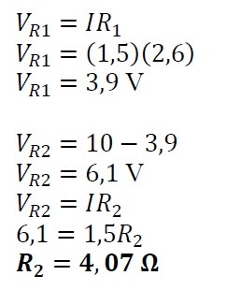 𝑹1= 𝟐𝟐,𝟔𝟔 𝛀 ✓ (4)

6.2.5

✓

✓

✓

* (4)

6.2.6 open S, circuit resistance increases ✓

so I through battery decreases ✓

by 𝑉=𝑒mf−𝐼r✓

𝑉 increases✓ (4)

**[28]**

**Question 7**

7.1.1 $\frac{V_{p}}{N_{p}}=\frac{V_{s}}{N_{s}}$ ✓ ∴ $N_{s}=\frac{(1000)(36)}{240}$ ✓✓ = 150 turns ✓ (4)

7.1.2 Pp = Ps ✓

*or* VpIp = Ps

(240)(Ip)✓ = 500 ✓

∴Ip = 2,08 A (3)

7.2.1 Motor as electrical energy → mechanical energy (1)

7.2.2 PQRS (1)

7.2.3 North (1)

7.2.4 Down (1)

7.2.5 No✓, there is no split ring commutator✓ (2)

7.3.1 The emf induced is directly proportional✓ to the rate of change of

magnetic flux✓ (flux linkage). (2)

7.3.2 (4)

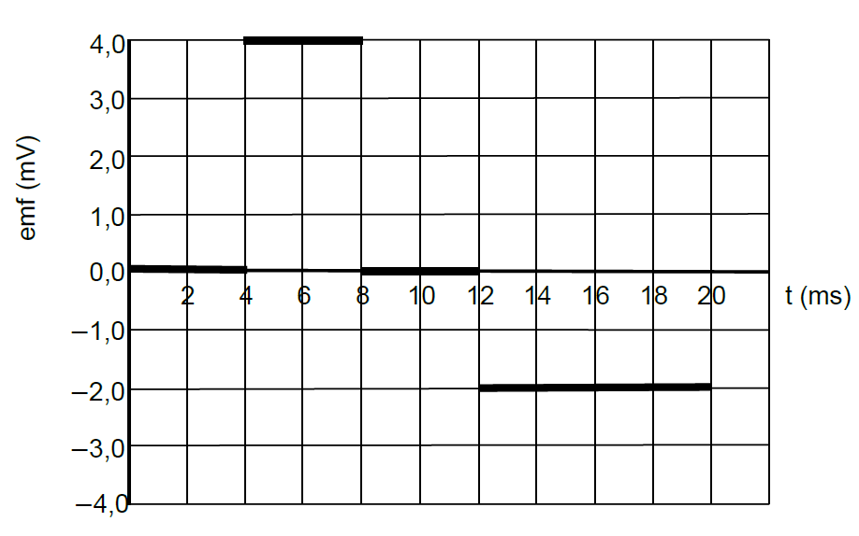

7.4.1 (iii) ✓ (1)

7.4.2 FDGHAE ✓✓ (2)

**[22]**

**Question 8**

8.1 *Threshold frequency is the minimum frequency✓ of incident radiation*

*at which electrons will be emitted from a particular metal. ✓*  (2)

8.2 *E = hf* ✓

*E* = (6,6 × 10–34)(4,4 × 1014) ✓

***E* = 2,90 × 10–19 J**✓ (3)

8.3 If *f* > *f*0 then EK max increases as frequency increases. ✓ ✓

If *f* < *f*0 then EK max is zero and no electrons are ejected. ✓ (3)

8.4 B✓

*f*0 is double as W0 is double, therefore greater *x* intercept. ✓

Slope *= h* therefore constant slope✓ (3)

8.5 *hf* = W0 + EK max ✓

(6,6 × 10–34)(15 × 1014) ✓ = 2 (2,90 × 10–19)+ EK max ✓

**EK max = 4,1 × 10–19 J**✓ (4)

**[15]**