

HILTON COLLEGE
GRADE 12 TRIALS EXAMINATIONS
AUGUST 2018

PHYSICAL SCIENCE : PAPER 1 – MARK SCHEME

1.1 C✓✓
1.2 D✓✓
1.3 A✓✓
1.4 B✓✓
1.5 A✓✓
1.6 A✓✓
1.7 B✓✓
1.8 B✓✓
1.9 C✓✓
1.10 C✓✓ [20]

QUESTION 2
2.1.1 a physical quantity that has both magnitude✓ and direction✓ (2)

2.1.2 Fh = F cos ø ✓
= 500 x cos (50)✓
= 321,39N ✓ left (3)

2.1.3 Qcos(60) = 321,39 ✓
Q = 321,39 / cos(60);✓
Q = 642,78N ✓ (3)

2.1.4 weight = Psin(50) + Qsin(60) ✓
mg = 500sin(50) + 642,78sin(60)✓
m(9,8) = 383,02 + 556,66
m(9,8) = 939,68✓
m = 95,88kg✓ (4)

2.2.1 distance = 40 + 40 + 40 + 80✓

distance = 200 m✓ (2)

2.2.2 displacement = √402 + 802

displacement = 89,44 m✓✓

tan(𝜃) = opp / adj;
= 80 / 40 ✓
𝜃= tan ⁻¹ (2)
𝜃 = 63,43✓ S of E✓
⁰

Displacement = 89,44m on a bearing of 153,43º (5)

2.2.3 average speed = distance / time✓
= 200 / 25✓
= 8 m / s✓ (3)

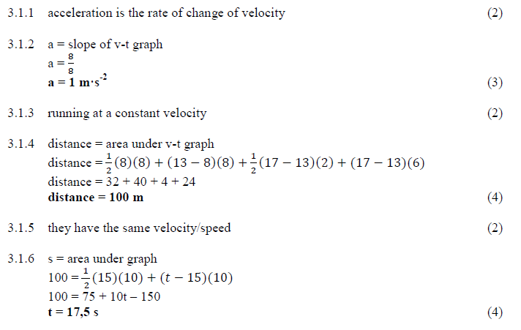
(1)
✓
Forwards ✓
3.2.1 Springbok exerts force on ground✓
Ground exerts force on springbok✓
Note: Not force of Earth on springbok as this can be a non-contact force (2)

3.2.2 The action reaction pairs act on different objects✓
Force of ground on springbok is greater than the weight of the springbok✓ (essential point)
By Newton’s 2nd Law, resultant force is upwards✓
Produces acceleration in that direction (3)

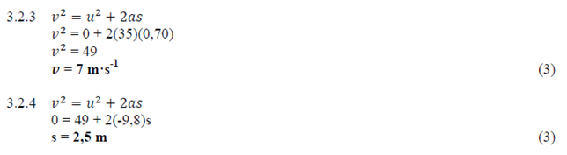

[27]
4.1 An object continues in its state of rest of uniform velocity✓ unless it is acted upon by a net or resultant force.✓ (2)
4.2
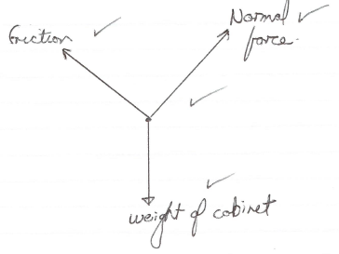 (3)

4.3 friction = W_{ǁ}
= mgsinø✓
= 60 x 9,8 x (sin 30)✓
= 294 N✓ up the slope✓ (4)
4.4 Fn = Wւ
= mgcosø✓
= 60 x 9,8 x (cos 30)✓
= 509,22N✓ (3)

4.5 μ= friction / Fn✓
= 294 / 509,22✓
= 0,58✓ (3)
4.6 decreases (No marks for ‘decreases UNLESS accompanied by proper reasoning)
Kinetic friction less than static friction✓✓ (2)

4.7 Fnet = mgsinø- friction✓
= 60 x 9,8 x sin(35) – 250✓
= 337,26 – 250
= 87,26N✓

Fnet = ma
87,26 = 60a✓
a = 87,26 / 60
a = 1,45 m / s² ✓ (5)
[22]
5.1 The toal linear momentum of an isolated system✓ remains constant✓ (2)

5.2
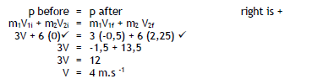
(4)
5.3
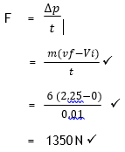 (3)
5.4 Y to X.✓ (or down the slope) … NOT: “down” (1)

5.5 The work done by a net force on an object✓ is equal to the change in the
kinetic energy of the object✓ (2)

5.6 Sin ø = opp / hyp
= 0,12 / XY
XY = 0,12 / Sin ø (2)
5.7 Fnet = Fg // slope + Ffric✓
= mg sin 𝜃 + 10
= 6 x 9,8 x sin 𝜃 ✓+ 10
= 58,8 sin 𝜃 + 10 ✓ (3)
5.8
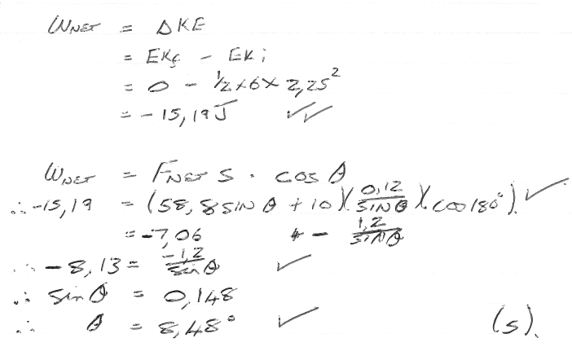

5.9 Mechanical energy at bottom = mechanical energy at top
KE (crate) + PE (crate) = KE (crate) + PE (crate)✓
KE (crate – bottom)) +0 = 0 + mgh (crate – top)
½ (1,2) v² = (1,2)(9,8)(0,65)✓✓
0,6 x V² = 7,644
V² = 12,74
V = 3,57 m/s✓ (4)

5.10 W_{eng} + W_{PE} = W_{KE} + W_{friction} ✓
W_{eng} = W_{KE} + W_{friction} - W_{PE}
= ½ x 6000 x (10² – 0²)✓ + (25 000 x 360)✓ - (6000 x 9,8 x 45)✓
= 300 000 + 9 000 000 – 2 646 000
= 6 654 000
= 6,65 x 10⁶ J ✓
Note: In order to get the allocated marks the signs applied to the working above
need to be correct. (5)

[31]
Alternate Options for 5.10

OPTION 2:
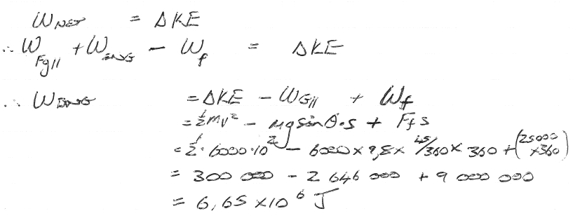

OPTION 3
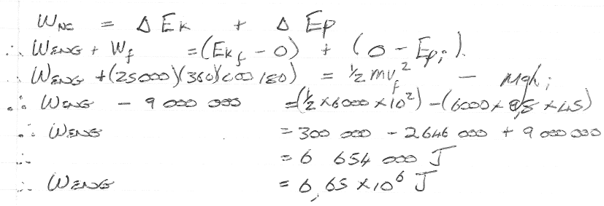

6.1 Any two particles in the universe attracts each other with a force that is directly
proportional to the product of their mass, but inversely proportional to the square
of the distance between them.  (2) (2)

6.2 
7,5 = (6,67 x 10⁻¹¹) x M / (590 000)²✓

M = 3,90 x 10²² kg✓ (3) (4)

6.3.1 The same  (1)

6.3.2 Greater  (1)

6.4 “The force per unit positive charge”  (2) (2)

6.5 When the two spheres were in contact, the total charge is distributed evenly
between the spheres.
After contact they have the same charge – hence repelling each other with an
electrostatic force.  (2)

6.6 [-3+(+4)]2 = 0,5nC 

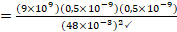

= 9,77 x 10⁻⁷ N to the right✓ (6)

[17]

Question 7

7.1 V₆ = IR✓ = 6 x 0,2✓
= 1,2V✓ (3)
7.2 EMF = V_{int} + V₆ + V_{ǁ}

But: V_{int} = IR =0,2 x 2 = 0,4V ✓

4 = 0,4 + 1,2 + V_{mn} ✓
V_{mn} = 4 – (1,2+ 0,4) ✓
= 2,4V ✓ (4)
7.3 R = V/I
= 2,4✓/0,2✓
= 12Ω✓ (3)

7.4 1/R_{t} = 1/R_{mn} + 1/R_{KL}✓
1/12 ✓= 1/R_{mn} + 1/₍₁₂₊₁₈₎ ✓
R_{mn} = 20Ω✓ (4)

7.5 I_{KL} = V/R = 2,4 / 30 = 0,08A✓
I_{MN} = 0,2 - 0,08
= 0,12A✓

V_{y} = 2,4 – 0,4
= 2,0V ✓

Ry = V/I = 2/0,12 ✓
Ry = 16,67Ω ✓ (5)

7.6 NO, power equals brightness. P = V²/R ✓
V is the same in the branches ✓therefore if R₁ not equal to R₂ then V²/R₁ is not equal to V²/R₂✓ (3)
Or in branches if I is different✓ (with same V) but with different resistances✓ then P=VI cannot be equal. ✓

7.7 E = I(R + r);
= 2(2 + r) …✓……… eqtn (a)
And: …= 3(1 + r) …✓……….eqtn (b)

Equate a and b:
4 + 2r = 3 + 3r
r = 1Ω✓
Emf = 2(2 + 1); = 6V✓ (4)
[26]

Question 8

8.1 The induced current flows in a direction to so as to set up a magnetic field✓ to oppose the change in magnetic flux.✓ (2)
8.2 Picture A✓ (1)
8.3 According to Lenz the top of the coil will be a South pole✓, therefore current flows anticlockwise when viewed from above.✓ (2)
8.4 Y✓ (1)
8.5 Two opposing effects as per Lenz’s law with,
top of coil being N (due to repelling N pole entering the top)✓
bottom of coil being N (due to attracting S pole leaving the bottom)✓
Opposing effects cancel✓ and induced emf is 0 (3)
8.6 Kinetic energy of magnet is greater the further it falls; or
Speed of bar magnet greater as it leaves✓
According to farady, greater induced emf due to greater rate of change of flux.✓ (2)
8.7 AC generator✓
Converts kinetic energy (due to wind) to electrical energy✓ (2)
8.8 the emf induced is directly proportional to the rate of change of magnetic flux.✓✓ (2)
8.9 Increase strength of magnets
Turn coil faster
Use more magnets at different angles to each other
Increase the number of turns on the coil
Use more coils at different angles (any two)✓✓ (2)
8.10 The coils is not cutting across the field lines✓,
So there is no flux linkage✓ (2)
8.11 ABCD✓ (1)
8.12 1,3, 6, 7, 5, 8 ✓✓ (2 marks of 0 marks) (2)
8.13 Graph 2✓ (1)
[23]

9.1 the minimum amount of energy needed to emit an electron from the surface of a metal✓✓ (2)

9.2

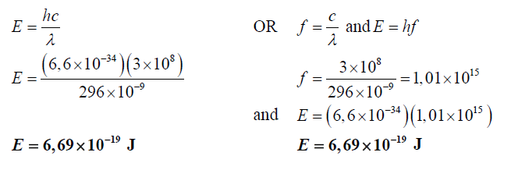
(3)
9.3 Sodium and Aluminium (-1 per wrong answer listed) (2)
9.4
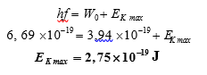✓✓✓
9.5 No, intensity increases the number of photons/electrons, and energy of electrons of photons/electrons is not affected by intensity.✓✓

OR

No, frequency same, energy not affected by intensity.✓✓
Note: NO MARKS for “NO” … must be fully explained.
(2)

