

HILTON COLLEGE

GRADE 12 TRIALS EXAMINATIONS

AUGUST 2017

**PHYSICAL SCIENCE : PAPER 2**

Time: 3 hours 200 marks

Examiner: Mr M Green

Moderator: Mr S van Wyk

**PLEASE READ THE FOLLOWING INSTRUCTIONS CAREFULLY**

1. This paper consists of:

* A question paper of **21 pages** and **11 questions.**
* Three pages of data and formulae (Pages 19, 20 and 21) which can be detached.

**2. Please check that your question paper is complete.**

3. Read the questions carefully.

4. It is in your own interest to write legibly and to set your work out neatly.

5. Use the data and formulae whenever necessary.

6. Number your answers in the same way as the questions are numbered.

7. All working must be shown.

8. Units need not be used in the calculations.

They **MUST** be shown in the answers, however.

9. No programmable calculators may be used.

**QUESTION 1**

## Choose the most correct alternative and write down the letter of your choice on the inside cover of your answer book. You may only mark one letter for each question.

1.1 CCl4 does not mix with water because CCl4 has ________ intermolecular forces while water has _______ intermolecular forces, respectively...

A London; ion-dipole B London; hydrogen bonding

C covalent; dipole-dipole D dipole-dipole; hydrogen bonding

1.2 The particles of a diamond crystal are held together by …

A ionic bonding

B Van der Waals forces

C hydrogen bonding

D covalent bonding

1.3 In an experiment, a 2g lump of zinc and 1g of powdered zinc are added separately to equal volumes of dilute sulphuric acid. The **solid line** in the graph below shows the volume of gas given off when the 2g lump is used.

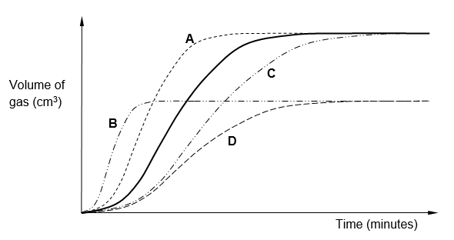

Which dotted line is obtained when 1 g of powdered zinc is used?

1.4 The graph below represents the change in potential energy against time for the following reaction:



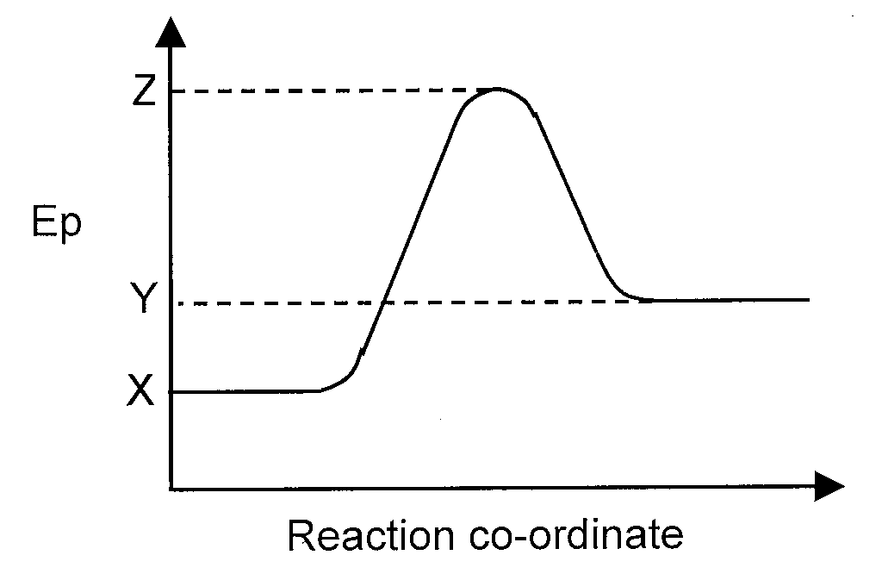

Which **ONE** of the following statements is correct?

A The heat of reaction for the forward reaction is Y – X

B The forward reaction is exothermic.

C The activation energy for the forward reaction is Z – Y

D The activation energy for the reverse reaction is Z – X

1.5 Consider the following equilibrium:

H2(g) + I­2(g) 2HI(g)

The volume of the equilibrium system is increased and a new equilibrium is established. Compared to the rates of the reactions in the original equilibrium, which of the following describes the rates of the forward and reverse reactions, as well as the KC in the new equilibrium?

|  |  |  |  |
| --- | --- | --- | --- |
|  | **Forward Rate** | **Reverse Rate** | **Kc** |
| A | increased | increased | unchanged |
| B | decreased | decreased | unchanged |
| C | decreased | increased | increases |
| D | unchanged | unchanged | decreases |

**[20]**

1.6 Consider the following equation of a reversible reaction:

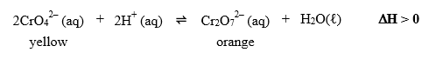

Which set of factors below would favour the formation of orange dichromate ions?

|  |  |  |
| --- | --- | --- |
|  | **Temperature** | **pH** |
| A | Decrease | Increase |
| B | Decrease | Decrease |
| C | Increase | Increase |
| D | Increase | Decrease |

1.7 In the reaction,



**X** represents the following:

A The acid SO42–

B The base SO42–

C The acid H2SO4

D The base H2SO4

1.8 Which of the following redox reactions will occur spontaneously? Refer to the Table of Reduction Potentials.

A Mg(s) + 2H+ ⭢ Mg2+ + H2(g)

B Cu(s) + 2H+ ⭢ Cu2+ + H2(g)

C 2Ag(s) + 2H+ ⭢ 2Ag+ + H2(g)

D Hg(l) + 2H+ ⭢ Hg2+ + H2(g)

1.9 A learner has a light bulb which only lights up when a voltage (potential difference) of 1,5 V is applied across its filament. Which one of the following standard cells will cause the bulb to light up? Refer to the Table of Standard Electrode Potentials.

|  |  |  |  |  |  |  |  |
| --- | --- | --- | --- | --- | --- | --- | --- |
| A | Sn2+ | + | Zn2+ | → | Zn | + | Sn4+ |
| B | H2 | + | Cu2+ | → | Cu | + | 2H+ |
| C | Cd | + | Au3+ | → | Cd2+ | + | Au |
| D | 2Cℓ– | + | Fe3+ | → | Cℓ2 | + | Fe |

1.10 What is the IUPAC name of the following compound?

**H**

**C**

**H**

**C**

**C**

**Br**

**Br**

**H**

**C**

**H**

A 1,1- dibromo-3-butyne.

B 4,4-dibromo-1-butyne.

C 2,4-dibromo-1-butyne.

D 4,4-dibromo-1-propyne.

**[10 x 2 = 20]**

**QUESTION 2**

2.1 Magnesium burns in air to form magnesium oxide according to the following balanced equation:

2Mg(s) + O2(g) → 2MgO(s)

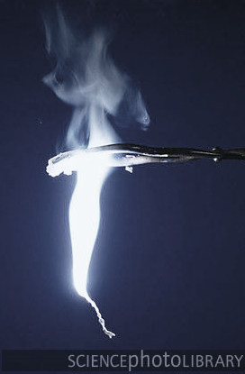

If 2,4g of magnesium combines with 0,8g of oxygen, which is at STP:

2.1.1 What does STP stand for? (1)

2.1.2 Calculate how many moles of magnesium **and** how many moles of oxygen is present. (2)

2.1.3 Which of the two substances will be used up completely? (1)

2.1.4 Determine how many moles of the other substance is in excess. (3)

2.2 20 g of impure iron reacts with excess sulphuric acid, releasing 5 dm3 of

hydrogen gas. The reaction is presented below:

Fe + H2SO4 🡪 FeSO4 + H2

2.2.1 Calculate the number of moles of hydrogen gas released. (2)

2.2.2 Write down the number of moles of pure Fe which reacted. (1)

2.2.3 Calculate the percentage purity of the iron. (3)

2.3 Consider the balanced equation shown below. The yield for the production of

water is 68,7%.

2 HNO3 + NO 🡪 3 NO2 + H2O

2.3.1 If 44,1 g of HNO3 reacts completely with nitrogen monoxide, calculate

the theoretical mass of water which is produced. (4)

2.3.2 Considering the yield for this reaction (68,7%), now calculate the actual

mass of water which is produced. (2)

**[19]**

**QUESTION 3**

Both aluminium fluoride (AℓF3) and phosphorous trifluoride (PF3) contain fluorine. Aluminium fluoride is a colourless solid used in the production of aluminium, whilst phosphorous trifluoride is a poisonous, colourless gas.

3.1 Define *intermolecular force.* (2)

3.2 Explain the difference between a *covalent bond* and an *ionic bond* (2)

3.3 Name the type of chemical bond between particles in:

3.3.1 AℓF3 (1)

3.3.2 PF3 (1)

3.4 Draw the Lewis structures for

3.4.1 AℓF3 (2)

3.4.2 PF3 (2)

The boiling points of four compounds of hydrogen, are given in the table below. The questions which follow refer to this table.

|  |  |
| --- | --- |
| **Formula** | **Boiling point (oC)** |
| CH4 | -164 |
| NH3 | -33 |
| H2O | 100 |
| SiH4 | -112 |

3.5 Fully explain the difference in boiling points between:

3.5.1 CH4 and NH3 by referring to their type of intermolecular forces. (3)

3.5.2 CH4 and SiH4 by referring to their molecular sizes. (3)

3.6 Write down the formula from the table that represents the following

3.6.1 ONE polar compound (1)

3.6.2 ONE non-polar compound (1)

**[18]**

**QUESTION 4**

Mg(s) + 2 HCl(aq) 🡪 MgCl2(aq) + H2(g)

An experiment to investigate the rate of the above reaction was carried out as shown in the diagram below.

* A divided flask was used to keep the reactants  
  apart initially.

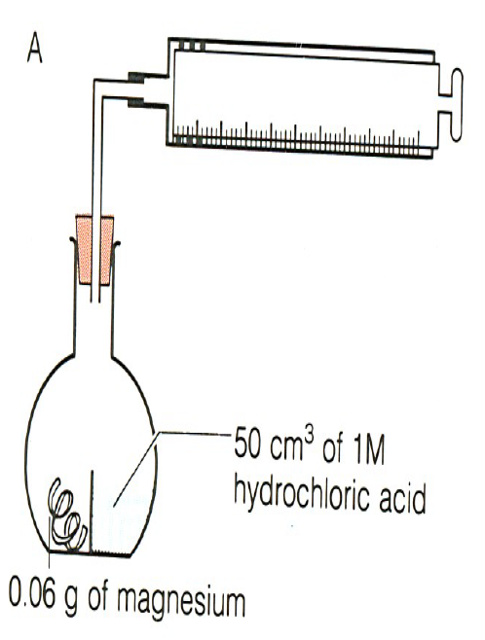

* The stop-watch was started once the flask was   
  tipped up to mix the chemicals.
* The volume of H2(g) collected was measured as   
  a function of time.
* The temperature was kept constant for all

experiments.

* The molar gas volume at the temperature used   
  is 24 dm3.mol-1.

|  |  |  |  |
| --- | --- | --- | --- |
| Experiment | Mass Mg (g) | Volume HCl (cm3) | [HCl] (mol.dm-3) |
| A | 0.06 | 50 | 1 |
| B | 0.03 | 50 | 1 |
| C | See diagram | | |
| D | See diagram | | |

Molecular diagrams of the initial reaction mixture for Experiments A, C and D are shown below.

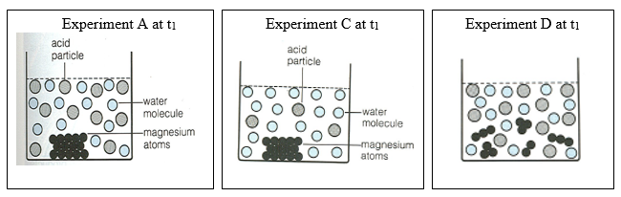

4.1 Using the diagram of Experiment A as a reference, deduce what factor is being investigated in…

4.1.1 Experiment C; and

4.1.2 Experiment D? (2)

4.2 Use the data provided for Experiment A to determine which reactant was in

excess and hence prove that 60 cm3 of H2(g) would be collected at this

temperature as shown in the graph below. (5)

Refer to the graph below and answer the questions which follow.

t1 t2 t3 time(s)

60

0

Volume H2(g) (cm3)

A

4.3 What does the gradient of this graph represent? (1)

4.4 Name and explain two possible reasons why the gradient of the graph is

less steep at t2 compared to t1. You should refer to the collision theory in

your answer. (4)

The rate of this reaction could also be investigated by measuring the mass loss of

an open flask as a function of time.

4.5 It is a law of nature that “matter is conserved” i.e. mass cannot be lost in a

chemical reaction. Why would the mass of an open flask decrease as this

reaction proceeds? (1)

4.6 Calculate the mass of H2(g) that would be produced in Experiment A. (2)

4.7 Comment on which of the two experimental techniques is preferable in

this case (measuring volume produced or measuring mass loss).

Justify your answer. (2)

**[17]**

**QUESTION 5**

A fertiliser company produces ammonia on a large scale at a temperature of 450oC. The balanced equation below represents the reaction that takes place in a sealed 2 dm3 container.

N2(g) + 3H2(g) ⇌ 2NH3(g) ∆H < 0

To meet an increased demand for fertiliser, the management of the company instructs their engineers to make the necessary adjustments to the dynamic chemical equilibrium of the reaction to increase the yield of ammonia.

In a trial run on a small scale in the laboratory, an engineer makes adjustments to the equilibrium mixture. The graphs below represent the results obtained.

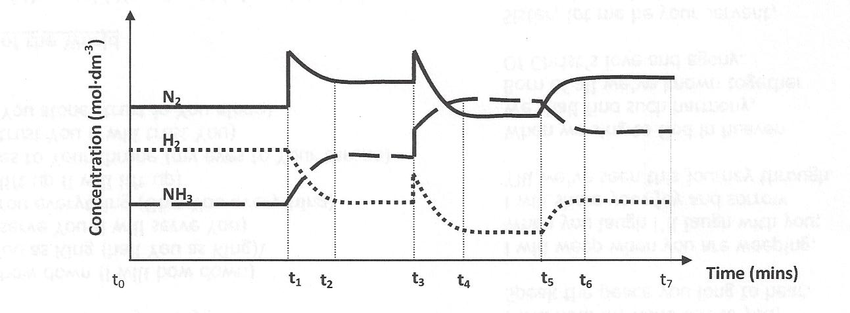5.1 Explain what is meant by the term “dynamic chemical equilibrium”. (2)

5.2 Give one time interval during which the reaction would have been in

dynamic chemical equilibrium. (1)

5.3 Using le Chatelier’s Principle, identify and explain the changes made to the

equilibrium mixture between each of the following times:

5.3.1 t1 and t2 (3)

5.3.2 t5 and t6 (3)

5.4 At t3, both the reactants and product showed a sudden increase in concentration.

5.4.1 What do you think happened at this point to cause the increase in

concentration? (1)

5.4.2 Using le Chatelier’s Principle, explain how the equilibrium now re-

establishes itself between t3 and t4. (3)

5.5 At t7, the following amounts of reactant and product were present at equilibrium

at a temperature of 450oC :

• 1,28 mol of H2,

• 49,6 g of N2

• 12,31 dm3of NH3 gas at STP

The volume of the reaction container is 2 dm3

5.5.1 Write down an expression for the equilibrium constant (Kc) for this

reaction. (2)

5.5.2 Calculate the value of Kc for this reaction at 450oC. (7)

5.5.3 What would happen to the value of the equilibrium constant (Kc)

calculated above, under the following conditions ?

(Simply answer INCREASE, DECREASE or STAY THE SAME)

5.5.3.1 N2 (g) is removed from the system.

5.5.3.2 The temperature is decreased to 350oC.

5.5.3.3 The size of the reaction vessel is increased. (3)

**[25]**

**QUESTION 6**

The acid ionisation constants, Ka, for the hypothetical acids H2X, HY and HZ, in water at 25̊ C, are given in the table below.

|  |  |
| --- | --- |
| **Acid** | **Ka** |
| H2X | 2,8 x 10-3 |
| HY | 1,2 x 106 |
| HZ | 6 x 10-4 |

6.1 Define the term *acid* (in terms of Lowrey-Bronsted model). (1)

6.2 Explain the difference between a strong acid and a weak one. Give an

example of a weak acid from the table above. (3)

6.3 From the table above, give an example of a polyprotic acid. (1)

6.4 Which acid, H2X, HY or HZ, will have the lowest pH. Justify your choice.

Assume that the concentrations of the acids are the same. (2)

6.5 HY is added to ammonia to make a salt. Give the formula of the salt. (1)

**[8]**

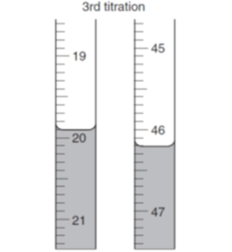**QUESTION 7**

A pupil titrates a strong acid, sulphuric acid, with sodium hydroxide to produce sodium sulphate and water.

H2SO4 + 2NaOH 🡪 Na2SO4 + 2H2O

Three reading are taken so that on average 27cm3 of acid is required to neutralize 25cm3 of a standardized solution of sodium hydroxide of concentration 0,2mol.dm-3

7.1 Calculate the volume for the 3rd titration as shown in the diagram. The

diagram shows the start and end reading on the burette. (2)

7.2 Bromothymol blue changes colour around pH 7. Explain why it is a

suitable indicator for this titration. (2)

7.3 Write down an equation for the ionization of sulphuric acid in water. (2)

7.4 Strong acids are known to conduct electricity. Compare the conductivity of the

acid solution to that of the solution where the bromothymol blue changes colour. (2)

7.5 Define the term *neutralisation* in a titration? (2)

7.6 Consider a solution of the salt ammonium sulphate [ (NH4)2SO4 ]

7.6.1 Define a *salt*. (2)

. 7.6.2 Use an equation to show the hydrolysis of ammonium sulphate. (3)

7.6.3 Name the compounds that need to react to produce ammonium sulphate. (2)

7.6.4 Predict the pH of this solution. (1)

**[18]**

**QUESTION 8**

The galvanic cell represented in the diagram below consists of a Mg electrode dipped into a Mg(NO3)2 solution, and a Pb electrode dipped into a Pb(NO3)2 solution. Assume that the cell operates under standard conditions.

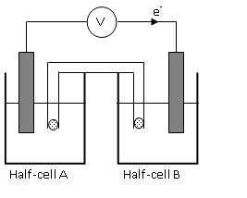

8.1 What energy conversions take place in this cell? (2)

8.2 State TWO standard conditions under which this cell operates. (2)

8.3 Write down the half-reaction that takes place in half-cell A. (2)

8.4 Write down the cell notation for this cell. (2)

8.5 Calculate the emf of this cell. (3)

8.6 How will each of the following changes influence the value of the cell's emf

calculated in QUESTION 8.5? Write down only INCREASES,

DECREASES or REMAINS THE SAME.

8.6.1 An increase in [Mg2+(aq)] (1)

8.6.2 An increase in [Pb2+(aq)] (1)

8.7 In which direction, from half-cell A to B or from half-cell B to A, do cations

move within the salt bridge to maintain electrical neutrality?

Explain how you arrived at your answer. (3)

**[16]**

**QUESTION 9**

Consider the following balanced chemical equation for the reaction taking place in a

galvanic cell under standard conditions:

2Cr(s) + 3Pb2+ (aq) → 2Cr3+ (aq) + 3Pb(s)

9.1 Write down the symbol of the oxidising agent in this reaction. (1)

9.2 The cell delivers a current of 0,2 A for 50 minutes. Using the formula Q = It

calculate the charge delivered by the cell **and** hence the number of electrons

that are transferred. (Note: charge on an electron = 1,6 x 10-19C) (4)

9.3 Calculate the loss in mass of the anode? (Take your answer to 4 decimal

places or 3 significant figures.) (4)

The diagram below is a simplified representation of one of the electrolytic cells used

in the chlor-alkali industry. The letters **P** and **Q** represent the two gases formed

during this process.

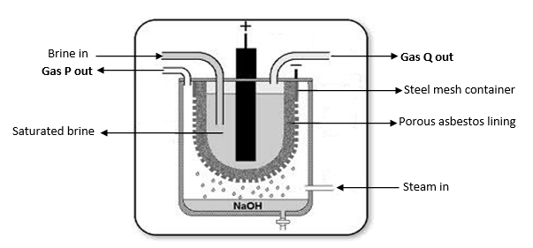

9.4 What is “brine”? (1)

9.5 Write down the **chemical formulae** of the gases **P** and **Q**. (2)

9.6 Use the Redox Table to explain why sodium metal is NOT one of the products

of this process. (2)

9.7 Write down the complete balanced equation for the reaction taking place   
in this cell. (2)

9.8 Do a calculation to explain why this reaction is not spontaneous. (3)

9.9 What is the name of the cell type depicted in the diagram and give a reason as

to why it is getting phased out. (2)

**[21]**

**QUESTION 10**

Consider the following organic compounds below, represented by their condensed or molecular formula:

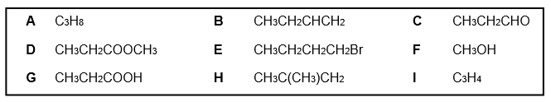

10.1 Write a balanced equation for the combustion of the alkane shown above. (3)

10.2 To which homologous series does compound **F** belong? (1)

10.3 Compound **D** is formed by a process called esterification. Using structural

formulae, show how this ester is formed. Name all the reactants and

products in this reaction. (7)

10.4 Compound **E** is formed from compound **B**.

10.4.1 Name this type of reaction. (1)

10.4.2 Name the other compound that reacted with compound **B**. (1)

10.5 Name the functional group in compound **G**. (1)

10.6 Give the IUPAC name of compound **H**. (2)

10.7 What type of intermolecular force exists between the molecules of

compound **F**? (1)

10.8 State one physical property of compound **F** as a result of the intermolecular

force mentioned in 10.7. (1)

**[18]**

**QUESTION 11**

11.1 Define each of the following terms:

11.1.1 *Functional group*  (2)

11.1.2 *Isomer* (2)

11.2 Draw the following molecules using the formula shown in brackets:

11.2.1 2,4-di-bromo-hex-2-ene **(semi structural formula)** (2)

11.2.2 3-ethyl-2-methyl-pentane **(condensed formula)** (2)

11.3 The table below shows the boiling points of five alkanes.

|  |  |
| --- | --- |
| **Alkane** | **Boiling point (°C)** |
| Methane | -162 |
| Ethane | -89 |
| Propane | -42 |
| Butane | 0 |
| Pentane | 36 |

11.3.1 Name the intermolecular force that exists between alkane molecules. (1)

11.3.2 Briefly explain why methane has a much lower boiling point compared

to pentane. (2)

11.4 Study the various reaction pathways shown below and answer the questions

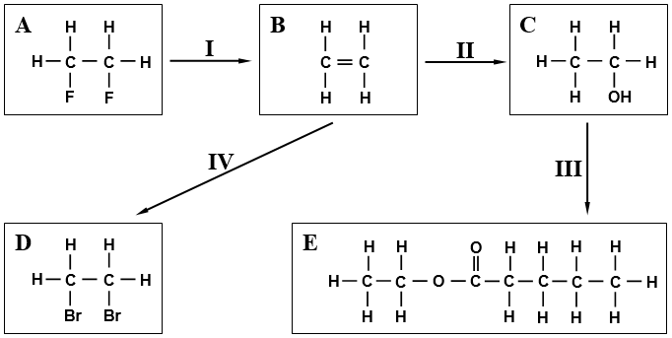that follow:

11.4.1 To which homologous series does organic compound **A** belong? (1)

11.4.2 What type of reaction is represented by reaction **I**? (1)

11.4.3 Name the reactant that needs to be added to **B** to complete reaction **II**. (1)

11.4.4 Name TWO substances that must be added to **C** in order to produce

The product in reaction **III**. (2)

11.4.5 Draw and name a structural isomer of organic molecule **E** that is

found in a different homologous series. (3)

11.4.6 What would you observe when bromine liquid (Br2) liquid is added

to **B** in reaction **IV**. (1)

**[20]**

**TOTAL: 200 MARKS**

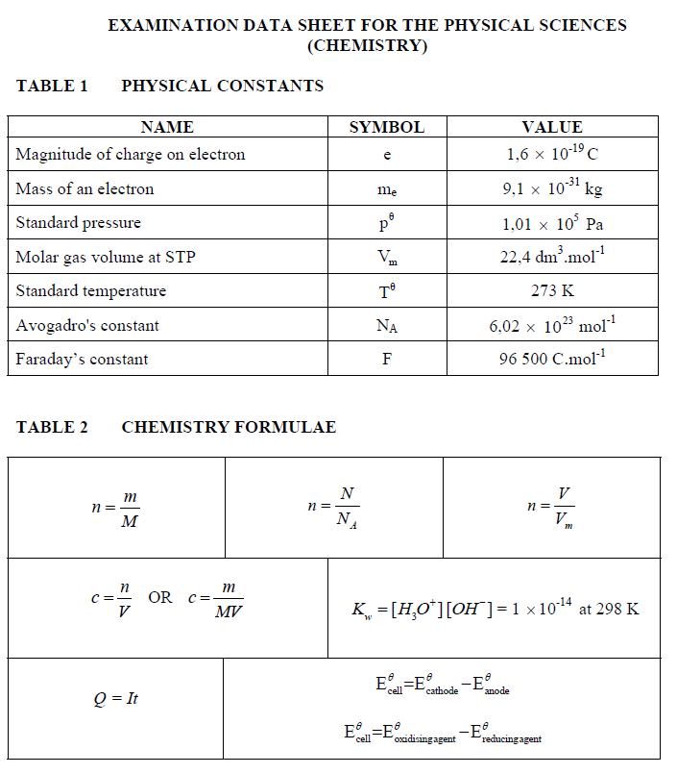

**PERIODIC TABLE**



**TABLE 4B STANDARD ELECTRODE POTENTIALS**

|  |  |  |  |  |  |
| --- | --- | --- | --- | --- | --- |
|  | Half –reaction | | | E°/ volt | **Increasing reducing ability** |
| **Increasing oxidising ability** | Li+ + e- | ⇌ | Li | -3.05 |
| K+ + e- | ⇌ | K | -2.93 |
| Cs+ + e- | ⇌ | Cs | -2.92 |
| Ba2+ + 2e- | ⇌ | Ba | -2.90 |
| Sr2+ + 2e- | ⇌ | Sr | -2.89 |
| Ca2+ + 2e- | ⇌ | Ca | -2.87 |
| Na+ + e- | ⇌ | Na | -2.71 |
| Mg2+ + 2e- | ⇌ | Mg | -2.37 |
| A3+ + 3e- | ⇌ | A | -1.66 |
| Mn2+ + 2e- | ⇌ | Mn | -1.18 |
| 2H2O + 2e- | ⇌ | H2(g) + 2OH- | -0.83 |
| Zn2+ + 2e- | ⇌ | Zn | -0.76 |
| Cr2+ + 2e- | ⇌ | Cr | -0.74 |
| Fe2+ + 2e- | ⇌ | Fe | -0.44 |
| Cd2+ + 2e- | ⇌ | Cd | -0.40 |
| Co2+ + 2e- | ⇌ | Co | -0.28 |
| Ni2+ + 2e- | ⇌ | Ni | -0.25 |
| Sn2+ + 2e- | ⇌ | Sn | -0.14 |
| Pb2+ + 2e- | ⇌ | Pb | -0.13 |
| Fe3+ + 3e- | ⇌ | Fe | -0.04 |
| 2H+ + 2e- | ⇌ | H2(g) | 0.00 |
| S + 2H+ + 2e- | ⇌ | H2S(g) | +0.14 |
| Sn4+ + 2e- | ⇌ | Sn2+ | +0.15 |
| Cu2+ + e- | ⇌ | Cu+ | +0.16 |
| SO42- + 4H+ + 2e- | ⇌ | SO2(g) + 2H2O | +0.17 |
| Cu2+ + 2e- | ⇌ | Cu | +0.34 |
| 2H2O + O2 + 4e- | ⇌ | 4OH- | +0.40 |
| SO2 + 4H+ + 4e- | ⇌ | S + 2H2O | +0.45 |
| I2 + 2e- | ⇌ | 2I- | +0.54 |
| O2(g) + 2H+ + e- | ⇌ | H2O2 | +0.68 |
| Fe3+ + e- | ⇌ | Fe2+ | +0.77 |
| Hg2+ + 2e- | ⇌ | Hg | +0.79 |
| NO3- + 2H+ + e- | ⇌ | NO2(g) + H2O | +0.80 |
| Ag+ + e- | ⇌ | Ag | +0.80 |
| NO3- + 4H+ + 3e- | ⇌ | NO(g) + 2H2O | +0.96 |
| Br2 + 2e- | ⇌ | 2Br- | +1.09 |
| Pt2+ + 2e- | ⇌ | Pt | +1.20 |
| MnO2 + 4H+ + 2e- | ⇌ | Mn2+ + 2H2O | +1.21 |
| O2 + 4H+ + 4e- | ⇌ | 2H2O | +1.23 |
| Cr2O72- + 14H+ + 6e- | ⇌ | 2Cr3+ + 7H2O | +1.33 |
| C2 + 2e- | ⇌ | 2C- | +1.36 |
| Au3+ + 3e- | ⇌ | Au | +1.42 |
| MnO4- + 8H+ + 5e- | ⇌ | Mn2+ + 4H2O | +1.51 |
| H2O2 + 2H+ + e- | ⇌ | 2H2O | +1.77 |
| F2(g) + 2e- | ⇌ | 2F- | +2.87 |