

HILTON COLLEGE

GRADE 12 TRIALS EXAMINATION

AUGUST 2019

**PHYSICAL SCIENCE: PAPER 2**

**MARK SCHEME**

**Question 1**

1.1 A

1.2 D

1.3 C

1.4 B

1.5 D

1.6 A

1.7 A

1.8 B

1.9 B

1.10 A

**[2 x 10 = 20]**

**Question 2**

2.1 A measure of the tendency of an atom to attract a bonding pair

of electrons.✓✓ (2)

2.2 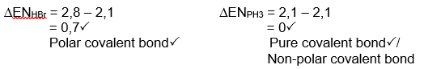(4)

2.3.1 Oxygen or fluorine (1)

2.3.2 Hydrogen fluoride (1)

2.3.3 aluminium oxide or sodium chloride (1)

2.3.4 aluminium oxide or sodium chloride (1)

2.3.5 hydrogen fluoride (1)

2.3.6 neon (1)

2.3.7 copper (1)

2.3.8 diamond (1)

2.4 Hydrogen must be bonded to:

A small atom✓

Highly electronegative✓

With at least 1 lone pair of electrons✓ (3)

2.5 Water has two lone pairs and 2 hydrogen atoms so it can **form 4 hydrogen bonds per molecule**. ✓

With only one lone pair, NH3 will have two hydrogens not contributing to the hydrogen bonding so overall **forms just 2 hydrogen bonds per molecule**✓

More energy required to overcome the hydrogen bonds in water✓ and hence a higher boiling point (3)

**[20]**

**QUESTION 3**

3.1 the mass in grams of one mole of that substance✓✓ (2)

3.2 n = m/M

= 1/252✓

= 0.00397 mol✓

N = nNA

= 0.00397 x 6.02 x 1023

= 2.39 x 1021✓

NCr = 2 x 2.39 x 1021 = 4.78 x 1021 Cr atoms✓ (4)

3.3.1 2NaOH (aq) + MgCl2 (aq)🡪 2NaCl (aq) + Mg(OH)2 (s)

nNaOH = nMgCl2 = cV

= 1 x 0.03 √

= 0.03 moles √

2 NaOH : 1 MgCl2  √

Therefore 0.03 mole NaOH requires 0.015 moles MgCl2

Thus NaOH = LR √ (4)

3.3.2 MMg(OH)2) = n x M

= 0.015✓ x 58 ✓

=0.87 g ✓ (3)

3.4 n(Al) = 5/27

= 0.185 mol✓ (0.185/2*3 = 0.278)

n(DMM) = 25/230.6✓

= 0,108 mol✓ (0.108/3*2 = 0.072)

DMM is LR✓

0,108 mol DMM produces 0.108/3*2 = 0.072mol TMA✓

m(TMA) = nM

= 0.072 x 72✓

= 5.18 g TMA✓

% yield = actual / theoretical x 100

= 4,5/5,18 x 100

= 86.9%✓ (8) **[21]**

**Question 4**

4.1.1 exothermic ✓ (1)

4.1.2 Reactants must collide with Ek greater than the EA for the reaction✓

The reactants must have the correct molecular orientation✓ (2)

4.1.3 It increases the rate of the reaction✓ by reducing the activation energy✓ and remains unchanged by the end of the reaction. (2)

4.1.4 $∆$ H = Ep – Er

= -86 – 25 ✓

= - 111 kJ.mol-1 ✓✓(-1 no unit) (3)

4.1.5 A high energy, unstable, temporary transition state between the reactants

and the products✓✓ (2)

4.1.6 68 – (-86) = 154 kJ.mol-1 ✓✓ (-1 for a negative answer) (2)

4.2.1 Time: Stopwatch ✓

Gas: Syringe; or Mass: electronic scale ✓ (2)

4.2.2 t3 ✓ (1)

4.2.3 between t1 and t2 ✓ (1)

4.2.4

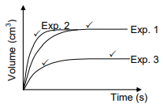

Exp 2: Initial gradient higher than Exp 1✓

Curve reaches same value as Exp 1, but earlier✓

Exp 3: Initial gradient lower than Exp 1✓

Curve reaches a smaller value for volume than Exp 1 (50% of the volume)✓, initial rate is less (less steep gradient)✓ (4)

**[20]**

**Question 5**

5.1.1 When an external stress is applied to a system in dynamic chemical equilibrium, the equilibrium point will change in such a way as to counteract the stress✓✓ (2)

5.1.2 Decrease✓

Increasing pressure means reaction will favour producing fewer moles of gas✓

This favours the reverse reaction thefore decreasing yield✓ (3)

5.1.3 increases rate✓

High temperature favours the endothermic reaction which is the forwards reaction, hence increasing yield✓ (2)

5.2.1 one (a system) in which mass is conserved inside the system but energy can enter or leave the system freely.✓✓ (2)

5.2.2 reversible reaction✓ (1)

5.2.3.1 larger than✓

Kc > 1✓ (2)

5.2.3.2 Mark allocation

* Calculate n(CO)equilibrium i.e. divide m by 28 g·mol-1 OR substitute 6 mol for equilibrium mole of CO. ✓
* Change in n(CO) = equilibrium n(CO) – initial n(CO) ✓
* USING ratio/GEBRUIK verhouding: CO2 : CO = 1 : 2 ✓
* Equilibrium n(CO2)= initial n(CO2) - change n(CO2). ✓
* Equilibrium mole of both CO2 and CO divided by 2 dm3. ✓
* Correct Kc expression (formulae in square brackets). ✓
* Substitution of concentrations into Kc expression. ✓
* Substitution of Kc value. ✓
* Final answer/ 4,28–4,29 (mol) ✓

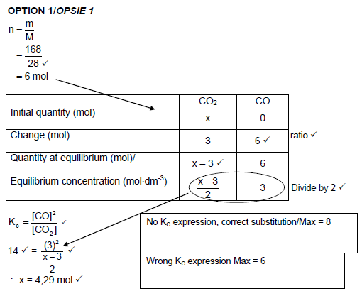

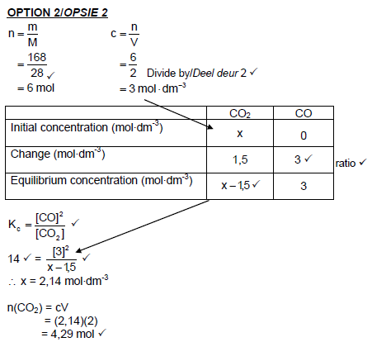 (9)

5.2.4.1 Remains the same ✓

5.2.4.2 Decrease ✓

5.2.4.3 Increase ✓ (3)

**[24]**

**QUESTION 6**

6.1 oxonium✓ (or hydronium) (1)

6.2 H2SO3 (acid) & HSO3-(base)✓✓

H3O+(acid) & H2O (base)✓ (3)

6.3.1 weak acid ionizes partially✓ in an aqueous solution✓ (2)

6.3.2 weak acid + strong base **🗸**🡪 basic salt**🗸 /** pH above 7 at equivalence point

thus phenolphthalein**🗸** (3)

6.4.1 a substance in which the hydrogen of an acid is replaced by a cation✓✓ (2)

6.4.2 ammonia✓ and sulphuric acid✓ or

Ammonium hydroxide✓ and sulphuric acid✓ (2)

6.4.3 (NH4)2SO4 + 2H2O 🡪 SO42- + 2NH3 + 2H3O+ ✓✓✓ (3)

NH4+ + H2O 🡪 NH3 + H3O+ (accept for 3 marks)✓✓✓

6.4.4 This is a **SAGS** explanation …

the measure of concentration of hydronium ion (H3O+) 🗸

… in water at 25oC ✓ (2)

6.4.5 any value **less than** 7✓ (1)

6.5.1 one of known concentration ✓✓ (2)

6.5.2 H2SO4 + 2KOH 🡪 K2SO4 + 2H2O products✓✓ ; balancing✓ (3)

6.5.3 n = CV; = 0,2 x (15/1000); = 0,003 mol✓

Ratio 2:1✓;

0,003 / 2 = 0,0015 mol✓ of H2SO4

C = n / V; = 0,0015 / (20/1000)✓;

ca = 0,075mol.dm-3 ✓ (5)

**[29]**

**QUESTION 7**

7.1 Anode Cr 🡪 Cr3+ + 3e- ✓✓ (2)

7.2 Ag+ ✓ (1)

7.3 Cr (s) / Cr3+ (aq, 1mol.dm-3)// Ag+( aq, 1mol.dm-3)/ Ag (s) at 250C

Correct cell notation ✓

Salt bridge ✓

Phase indicators ✓

Standard conditions ✓ (4)

7.4 Eocell = Eocathode – Eoanode =0,80 – (-0,74) = 1,54 V✓✓✓ (3)

7.5 Emf will increase✓. The forward reaction at the silver cathode will be favoured✓ due to the increase in concentration of the Ag+ ions✓. (3)

7.6.1 Ag+ + e- ⭢ Ag

Ratio 1: 1

n = Δc x V= (1 – 0,72)✓ x 0,25 = 0,07 mol of Ag+ ions reduced✓

Therefore: 0,07 mol of Ag produced (ratio 1: 1)

Gain in mass, m = n x M = 0,07 x 108✓ = 7,56 g of Ag deposited ✓ (4)

Marks awarded:

Change in C ✓

Conversion of volume to 0,25✓

Molar mass = 108 g.mol-1  ✓

Correct answer ✓

7.6.2 Mol Ratio Ag+: e-

1 : 1

4 x 10-4 : 4 x 10-4

1 mol of electrons are transferred for every mol of Ag+ reduced, Ag+ + e- 🡪 Ag

No. of electrons transferred = 4 x 10-4 x 6,02 x 1023 = 2,408 x 1020 electrons✓✓

Charge of one electron = 1,6 x 10-19C (data sheet)

∴charge transferred = 1,6 x 10-19 x 2,408 x 1020 = 38,528 C✓

Current, I = Q/t = 38,528 / 60 = 0,64 A✓✓ (5)

**Faraday constant method**

Q = n x F

Q = 4 x 10-4 x 96 500

Q = 38,6 C✓✓

**Q = 144,75 C**

**[22]**

7.6.2 Marking further explained …

Method 1:

Ratio (or implied) = 4 x 10-4 mol ✓

Electrons transferred ( x 6,02 x 1023) ✓

Charge transferred (no electrons x 1,6 x 10-19) ✓

Current = Q / t; = Q / **60** ✓

Answer ✓

Method 2:

Q = n x F (formula) ✓

= 4 x 10-4✓ x 96 500✓

= 38,6

Current = Q / t; = Q / **60** ✓

Answer ✓

**QUESTION 8**

8.1 electrical energy to chemical energy✓✓ (2)

8.2 Asbestos (1)

8.3.1  (2)

8.3.2  (2)

8.3.3  (2)

Note: -1 in total for 8.3.1 – 8.3.3 for using double arrows.

8.4.1

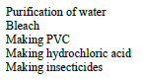 (1)

8.4.2

 (1)

8.5 Cl- ✓ (1)

8.6.1 Asbestos diaphragm is a non-selective diaphragm therefore Cl- as well as Na+ pass through into the cathode compartment. ✓

Membrane in membrane cell only allows Na+ ions to pass through ✓

Therefore NaCl can form in cathode compartment of asbestos cell but not of membrane cell ✓ (3)

8.6.2 membrane cell is cheaper (to run and to set up)✓

Asbestos cell is toxic; membrane cell is not ✓ (2)

**[17]**

**QUESTION 9**

9.1.1 An atom or group of atoms that form the centre of chemical activity in the molecule✓✓ (2)

9.1.2 Hydroxyl✓ (1)

9.1.3 4,4✓−di✓methylpentan−1✓−ol✓ (-1 for each error) (4)

9.2.1 (A series of similar compounds which have) the same functional group and have the same general formula, in which each member differs from the previous one by a single CH2 unit.✓✓ (2)

9.2.2 Alkenes✓ (1)

9.2.3 Double bond in correct place✓

2 methyl groups✓

Rest of molecule correct✓

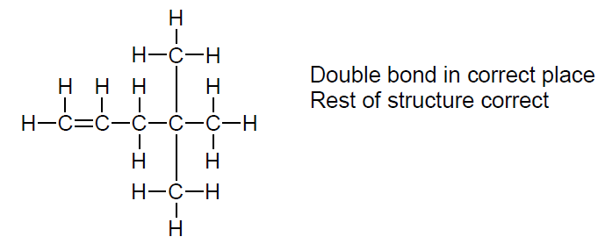 (3)

9.3.1 Halogenation / bromination ✓ (1)

9.3.2 CH2CHCH2C(CH3)2CH3 + Br2 ✓→ CH2BrCHBrCH2C(CH3)2CH3 ✓✓ (3)

9.4.1 Elimination (dehydration) ✓ (1)

9.4.2 Ester ✓ (1)

9.5 2C7H16O + 21O2 → 14CO2 + 16H2O (products✓✓) (balancing✓✓) (4)

9.6 CH2=CH−CH2−CH2−CH2−CH2−CH3 OR

CH2CHCH2CH2CH2CH2CH3 OR

CH2CH(CH2)4CH3 ✓✓ (2)

9.7.1 Addition (hydrogenation) ✓ (1)

9.7.2 Alkanes ✓ (1)

**[27]**