

HILTON COLLEGE

GRADE 12 TRIALS EXAMINATION

AUGUST 2019

**PHYSICAL SCIENCE: PAPER 2**

Time: 3 hours 200 marks

Examiner: Mr MJ Green

Moderator: Mr NC Robert

**PLEASE READ THE FOLLOWING INSTRUCTIONS CAREFULLY**

1. This question paper consists of 16 pages. A green Data Sheet of 3 pages (i-iii) is provided separately. Please make sure that your question paper is complete.

2. Read the questions carefully.

3. ALL of the questions in this paper must be answered.

4. Question 1 consists of 10 multiple-choice questions. There is only one correct answer to each question. The questions are to be answered on the inside cover of your Answer Book. The letter that corresponds with your choice of the correct answer must be marked with a cross as shown in the example below:



5. **START EACH QUESTION ON A NEW PAGE.**

6. Use the data and formulae whenever necessary.

7. Number your answers in the same way as the questions are numbered.

8. Unless instructed otherwise it is NOT necessary to give ‘state symbols’ (phase indicators) when asked to write a balanced chemical equation.

9. Show all necessary steps in calculations.

10. Where appropriate take your answers to 2 decimal places.

11. It is in your own interest to write legibly and to present your work neatly.

**QUESTION 1**

Answer these questions on the multiple-choice Answer Sheet on the inside front cover of your Answer Book. Make a cross (X) in the box corresponding to the letter representing the answer that you consider to be the most correct.

1.1 The chemical formula for beryllium chlorate is:

A Be(CℓO3)2

B Be2(CℓO3)

C Be3(CℓO2)

D BeCℓO3

1.2 The rate of a chemical reaction is most correctly defined as the ...

A time taken for a reaction to occur.

B speed at which a reaction takes place.

C change in the amount of reactants or products.

D change in the concentration of reactants or products per unit time.

1.3 Graph **Q** (the solid line) below was obtained for the reaction of 100 cm3 of a

0,1 mol∙dm-3 HCℓ solution with 20 g of magnesium powder. The magnesium is in excess.

Which graph (A, B, C or D) represents the reaction of 100 cm3 of a 0,1 mol∙dm-3 HCℓ solution with 30 g of magnesium pellets, at the same temperature as was the case when graph **Q** was produced?

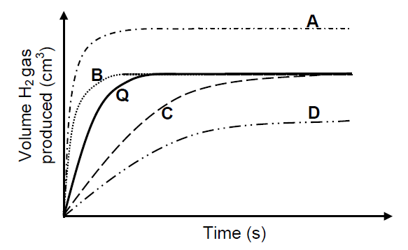

1.4 The energy changes represented by P, Q and R on the potential energy graph below take place during a reversible chemical reaction.

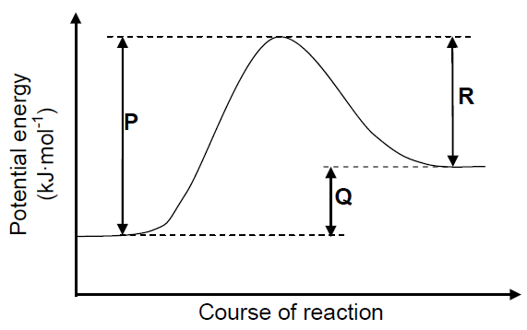

Which ONE of the following changes will decrease both P and R, but leave Q unchanged?

A A decrease in volume

B The addition of a catalyst

C A decrease in temperature

D A decrease in concentration

1.5 The reaction represented by the balanced equation below reaches equilibrium in a closed container.

Cℓ2(g) + H2O(ℓ) ⇌ Cℓ─(aq) + CℓO─(aq) + 2H+(aq)

Which ONE of the following reagents will favour the forward reaction when added?

A Hydrogen

B Sodium chloride

C Hydrogen chloride

D Sodium hydroxide

1.6 Consider the reaction represented by the balanced equation below.

H3PO4(aq) + H2O(ℓ) ⇌ H3O+(aq) + H2PO4-(aq)

Which ONE of the following is a conjugate acid-base pair?

A H3O+(aq) and H2O(ℓ)

B H3PO4(aq) and H2O(ℓ)

C H3PO4(aq) and H3O+(aq)

D H3O+(aq) and H2PO4-(aq)

1.7 The following half-reactions take place in a galvanic cell:

Co2+ + 2e- ⇌ Co and Aℓ3++ 3e- ⇌ Aℓ

Which ONE of the following is the cell notation for this cell?

A Aℓ ∣ Aℓ3+ ∥ Co2+ ∣ Co

B Aℓ ∣ Aℓ3+  ∥ Co  ∣ Co2+

C Aℓ3+ ∣ Aℓ ∥ Co2+ ∣ Co

D Co2+ ∣ Co ∥ Aℓ3+  ∣ Aℓ

1.8 Which ONE of the following is a NON-SPONTANEOUS redox reaction? Refer to the Table of Standard Reduction Potentials (Table 4).

A Zn(s) + 2HCℓ(aq) → ZnCℓ2(aq) + H2(g)

B Cu(s) + FeCℓ2(aq) → CuCℓ2(aq) + Fe(s)

C 2AgNO3(aq) + Cu(s) → Cu(NO3)2(aq) + 2Ag(s)

D 2Aℓ(s) + 3Ni(NO3)2(aq) → 2Aℓ(NO3)3(aq) + 3Ni(s)

1.9 Which one of the following organic compounds is an unsaturated hydrocarbon?

A C3H8

B C5H10

C CH3Br

D CH4

1.10 Ethene is reacted with hydrogen bromide to form product **P**. This product, **P**, then reacts in the presence of a hot, concentrated solution of sodium hydroxide in an ethanol solvent i.e. in the absence of water, to produce major product **Q**.

The flow diagram below represents the production of the organic compounds **P** and **Q**.



What is the molecular formula of compound **Q**?

A CH2CH2

B CH3CH3

C CH3CH2Br

D CH3CH2OH

**[20]**

**QUESTION 2**

2.1 Define *electronegativity.* (2)

2.2 Distinguish between polar and non-polar covalent bonds by calculating the difference in electronegativity of HBr and PH3. (4)

2.3 The following table contains eight substances.

|  |  |  |  |
| --- | --- | --- | --- |
| diamond | aluminium oxide | hydrogen fluoride | Neon gas |
| Fluorine gas | sodium chloride | copper | Oxygen gas |

Select substances from this table when answering the questions below. You may use the same substance for more than one of the answers.

2.3.1 a molecular substance with non-polar covalent bonds (1)

2.3.2 a molecular substance with polar covalent bonds (1)

2.3.3 a substance with ionic bonding (1)

2.3.4 substance with dipole-dipole intermolecular forces (1)

2.3.5 a substance with hydrogen bonding intermolecular forces (1)

2.3.6 a substance which has London forces between its atoms (1)

2.3.7 a substance which consists of positive atomic kernels surrounded by

a sea of delocalised electrons (1)

2.3.8 a substance which has a giant network structure in which the atoms

are held together by covalent bonds (1)

2.4. What are the three requirements for hydrogen bonding to take place? (3)

2.5 Why is the boiling point of water (100OC) so much higher than the boiling

point of ammonia (-33OC) when both have hydrogen bonding between their molecules? (3)

**[20]**

**QUESTION 3**

3.1 Define *molar mass*. (2)

3.2 How many Cr atoms would there be in a 1 g sample of (NH4)2Cr2O7? (4)

3.3 When 30 cm3 of a 1 mol.dm-3 sodium hydroxide solution is added to 30 cm3 of a 1 mol.dm-3 magnesium chloride solution, a white precipitate of magnesium hydroxide is formed according to the following balanced equation

2NaOH(aq) + MgCl2(aq)🡪 2NaCl(aq) + Mg(OH)2(s)

3.3.1 Identify the limiting reagent. Show all your working out. (4)

3.3.2 Calculate the mass of the precipitate formed. (3)

3.4 Trimethyl aluminium can be prepared from aluminium and dimethyl mercury as follows:

2Al(s) + 3Hg(CH3)2() 🡪 2Al(CH3)3() + 3Hg()

In one experiment, 5 g of aluminium was mixed with 25 g of dimethyl mercury and 4,5 g of trimethyl aluminium was recovered. Determine the percentage yield of trimethyl aluminium in this experiment. (8)

**[21]**

**QUESTION 4**

4.1 One of the steps in the preparation of sulphuric acid is represented by the following reversible reaction:

2SO2(g) + O2(g) ⮀ 2SO3(g)

The graph below shows the energy change during this reaction:

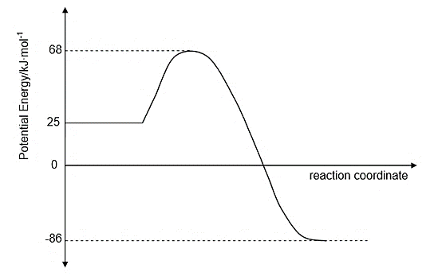

4.1.1 Is the reaction exothermic or endothermic? (1)

4.1.2 According to collision theory, give TWO conditions necessary for the reaction to take place. (2)

Vanadium pentoxide is now added as a catalyst in the above reaction.

4.1.3 Explain how the presence of a catalyst affects the rate of the reaction. (2)

4.1.4 Calculate the enthalpy change of this reaction. (3)

As shown on the graph, at 68 kJ.mol-1 an activated complex is formed.

4.1.5 Define the term *activated complex*. (2)

4.1.6 Calculate the activation energy for the reverse reaction. (2)

4.2 Dilute acids, indicated in the table below, react with EXCESS zinc in each of the three experiments to produce hydrogen gas. The zinc is completely covered with the acid in each experiment.

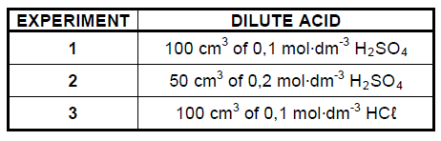

The volume of hydrogen gas produced is measured in each experiment.

4.2.1 Name TWO essential pieces of apparatus needed to determine the rate of

hydrogen production in this experiment. (2)

The graph below was obtained for Experiment 1.

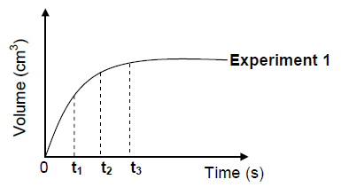

Use this graph and answer the questions that follow.

4.2.2 At which time (t1, t2 or t3) is the mass of zinc present in the flask

the smallest? (1)

4.2.3 In which time interval, between t1 and t2 OR between t2 and t3, does the largest volume of hydrogen gas form per second? (1)

4.2.4 Neatly **redraw** the graph for Experiment 1 in your ANSWER BOOK.

**On the same set of axes**, sketch the graphs that will be obtained for

Experiments 2 and 3.

Clearly label the three graphs as **Experiment 1**, **Experiment 2** and

**Experiment 3**. (4)

**[20]**

**QUESTION 5**

5.1 The industrial preparation of hydrogen gas is represented by the equation below.



The reaction reaches equilibrium at 1 000 °C in a closed container.

5.1.1 State Le Chatelier's principle. (2)

5.1.2 How will an increase in pressure at 1 000 °C (by decreasing the volume) affect the yield of hydrogen gas? Write down only INCREASES, DECREASES OR NO EFFECT. Explain the answer. (3)

5.1.3 Give TWO reasons why high temperatures are used for this reaction. (2)

5.2 Carbon dioxide reacts with carbon in a closed system to produce carbon

monoxide, CO(g), according to the following balanced equation:

CO2(g) + C(s) ⇌ 2CO(g) ΔH > 0

5.2.1 Define *closed system*. (2)

5.2.2 What does the double arrow indicate in the equation above? (1)

5.2.3 Initially an unknown amount of carbon dioxide is exposed to hot carbon at

800 °C in a sealed 2 dm3 container. The equilibrium constant, Kc, for the reaction at this temperature is 14. At equilibrium it is found that 168,00 g of carbon monoxide is present.

5.2.3.1 How will the equilibrium concentration of the product compare to that of the reactants? Choose from LARGER THAN, SMALLER THAN or EQUAL TO. Give a reason for the answer.

(No calculation is required.) (2)

5.2.3.2 Calculate the initial amount (in moles) of CO2(g) present. (9)

5.2.4 State how EACH of the following will affect the yield of CO(g) at equilibrium. Choose from INCREASES, DECREASES or REMAINS THE SAME.

5.2.4.1 More carbon is added at constant temperature. (1)

5.2.4.2 The pressure is increased. (1)

5.2.4.3 The temperature is increased. (1)

**[24]**

**QUESTION 6**

Sulphur dioxide gas, amongst other gases, is released as a pollutant when coal, a fossil fuel, is burned in a power station. This gas is highly soluble and will dissolve easily in atmospheric water to form sulphurous acid (H2SO3), a form of acid rain. The acid ionizes in water according to the following equation:

H2SO3 + H2O ⭢ H3O**+** + HSO3─

6.1 What is the name of the H3O+ ion produced in this reaction? (1)

6.2 Rewrite the equation and identify the acid-base conjugate pairs in this reaction. Ensure that you clearly label the acids and bases. (3)

6.3 Sulphurous acid is a weak acid.

6.3.1 Define a *weak acid*. (2)

6.3.2 Which of the following indicators would be most suitable to find the end point when sulphurous acid reacts with sodium hydroxide? Explain your reasoning.

|  |  |
| --- | --- |
| **Indicator** | **pH Range** |
| Phenolphthalein | 8,2 – 10 |
| Bromothymol Blue | 6,0 – 7,6 |
| Methyl Orange | 3,2 – 4,4 |

(3)

6.4 Consider a solution of the salt ammonium sulphate [(NH4)2SO4 ]

6.4.1 Define a *salt*. (2)

6.4.2 **Name** the acid and base that need to react to produce ammonium

sulphate. (2)

. 6.4.3 Use a balanced equation to show the hydrolysis of ammonium sulphate. (3)

6.4.4 Explain clearly what a pH reading represents? (2)

6.4.5 Predict the pH of the solution formed in 6.4.3. (1)

6.5 Brad finds some sulphuric acid solution in a bottle labelled ‘dilute sulphuric acid’. He wants to determine the concentration of the sulphuric acid solution. To do this, he decides to titrate the sulphuric acid against a **standard** potassium hydroxide (KOH) solution of concentration 0,2 mol.dm-3.

6.5.1 Define a *standard solution*? (2)

In the laboratory a schoolboy makes up a potassium hydroxide solution (KOH) to neutralize the sulphuric acid solution.

6.5.2 Write a balanced chemical equation for the reaction between H2SO4

and KOH. (3)

6.5.3 During the titration he finds that 15 cm3 of the KOH solution neutralizes

20 cm3 of the H2SO4 solution. Calculate the concentration of the

H2SO4 solution. (5)

**[29]**

**QUESTION 7**

Consider a galvanic cell set up under **standard conditions** between Chromium (Cr) in a solution of chromium ions and Silver (Ag) in a solution of silver ions.

7.1 Give the half reaction occurring at the anode. (2)

7.2 Write down the symbol of the oxidising agent. (1)

7.3 Write down the cell notation including standard conditions and all phase

indicators. (4)

7.4 Calculate the emf of the cell under standard conditions. (3)

7.5 How will the emf of the cell be affected if the concentration of Ag+ ions is

increased by adding crystals of silver nitrate to the Ag+/Ag half cell? Fully

explain your answer. (3)

7.6 After the cell has been operating for a while the concentration of silver ions in the silver half cell has decreased to 0,72 mol.dm-3. The volume of the solution in this cell is 250 cm3.

Hint: The reaction starts at standard conditions.

7.6.1 Calculate the mass of silver that has been deposited on the cathode. (4)

7.6.2 Calculate the current produced by the cell if 4 x 10-4 mol of Ag is

deposited per minute. (5)

**[22]**

**QUESTION 8**

The diaphragm cell (shown in the diagram below) is used in industry for the production of chlorine from the electrolysis of an aqueous solution of saturated sodium chloride.

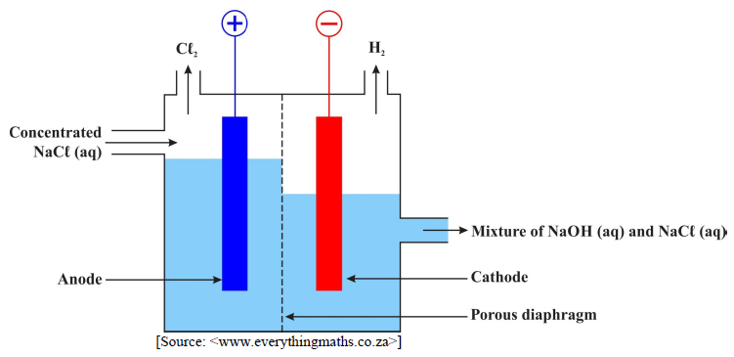

8.1 Describe the energy conversion taking place in this cell. (2)

8.2 Name the substance from which the diaphragm is made. (1)

8.3 Write down a chemical equation to represent:

8.3.1 The anode half-reaction. (2)

8.3.2 The cathode half-reaction. (2)

8.3.3 The net cell reaction. (The equation must be balanced.) (2)

8.4 State one use for each of the following products of this process:

8.4.1 Chlorine (1)

8.4.2 Hydrogen (1)

8.5 Give the chemical symbol of the reducing agent in this process. (1)

8.6 In many countries the diaphragm cell has been replaced by the membrane cell as shown in the diagram below.

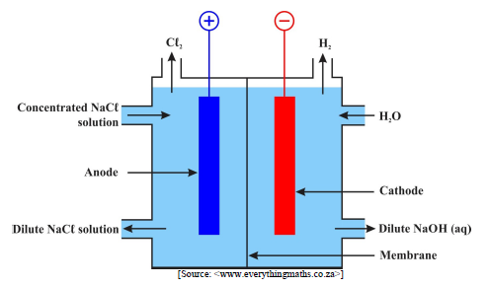

8.6.1 The sodium hydroxide produced in the diaphragm cell also contains

sodium chloride. This, however, is not the case with the sodium

hydroxide produced in the membrane cell. Account for this difference. (3)

8.6.2 State TWO advantages, other than the higher purity of the NaOH

solution produced, that the membrane cell has over the diaphragm

cell. (2)

**[17]**

**QUESTION 9**

The following sequence of reactions shows the production of compound Z, a DIHALOALKANE, from compound X (a branched alcohol) using organic reactions 1 and 2.

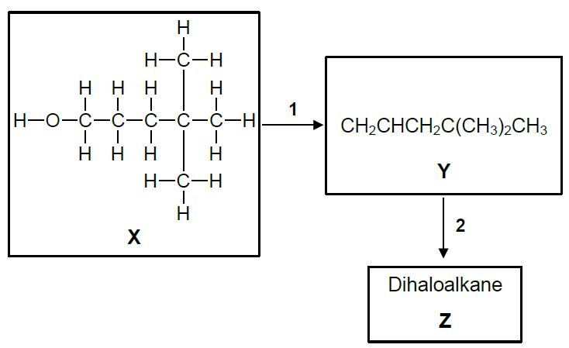

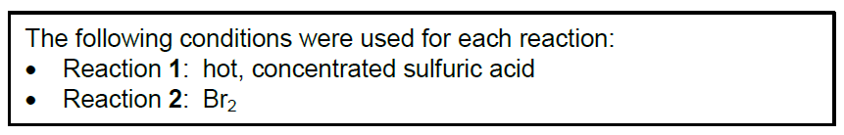

9.1 9.1.1 Define *functional group*. (2)

9.1.2 NAME the functional group of compound X. (1)

9.1.3 Write down the IUPAC name of compound X. (4)

9.2 9.2.1 Define *homologous series*. (2)

9.2.2 Identify the homologous series of compound Y. (1)

9.2.3 Draw the full structural formula of compound Y. (3)

9.3 9.3.1 NAME the **specific** type of addition reaction represented by reaction 2. (1)

9.3.2 Using condensed-structural formulae, write down the chemical equation

for reaction 2. (3)

9.4 9.4.1 Identify the TYPE of reaction represented by reaction 1. (1)

9.4.2 NAME the homologous series of the organic product that would be

produced if compound X were treated with a carboxylic acid in the

presence of hot, concentrated sulfuric acid. (1)

9.5 Using molecular formulae, write a balanced chemical equation for the complete combustion of compound X. (4)

9.6 Write down the condensed-structural formula of an UNBRANCHED, CHAIN

isomer of compound Y. (2)

9.7 Compound Y is now treated with hydrogen gas in the presence of a hot nickel

catalyst.

9.7.1 Identify the TYPE of reaction that occurs. (1)

9.7.2 NAME the homologous series of the organic product formed. (1)

**[27]**

----------------------------------- **Total: 200 marks** ----------------------------------