GAUTENG
PRELIM EXAMS

GRADE 12

SEPTEMBER 2019

INFORMATION TECHNOLOGY P2

MARKS: 150

TIME: 3 hours

This question paper consists of 17 pages (including cover page).

__
INSTRUCTIONS AND INFORMATION
1. | This question paper consists of SIX sections:
 | SECTION A: Short questions | (15)
 | SECTION B: System Technologies | (26)
 | SECTION C: Communication and Network Technologies | (22)
 | SECTION D: Data and Information Management | (24)
 | SECTION E: Solution Development | (30)
 | SECTION F: Integrated Scenario | (33)

- Read ALL the questions carefully.

- Answer ALL the questions.

- The mark allocation is usually an indication of the number of facts/reasons required.

- Number questions correctly according to the numbering system used in this question paper.

- Write neatly and legibly.

SECTION A: SHORT QUESTIONS

Question 1

1.1 Various options are provided as possible answers to the following questions. Choose the answer and write only the letter (A–D) next to the question number (1.1.1–1.1.5) in the ANSWER BOOK, for example 1.1.6 D.

 | 1.1.1 | A network security system that monitors the incoming and outgoing network traffic and is based on pre-determined security rules.
 |  | A Antivirus program
 |  | B Firewall software
 |  | C Spyware
 |  | D Windows Defender | (1)
 | 1.1.2 | Web browser plug-ins give extra functionality to web browsers. Which one of the following is not an example of a plug in?
 |  | A Java
 |  | B Quicktime
 |  | C Google Earth
 |  | D Youtube | (1)
 | 1.1.3 | The result of the expression 7 MOD 5 + 10 DIV 3:
 |  | A 5
 |  | B 4
 |  | C 3
 |  | D 2 | (1)

 | 1.1.4 | Which of the following statements is not an advantage of the use of an app rather than a web browser?
 |  | A Less data transfered
 |  | B Slow reaction time
 |  | C Automatic updates
 |  | D Better interface | (1)
 | 1.1.5 | The protocol used to send e-mails via the Internet.
 |  | A POP3
 |  | B FTP
 |  | C SMTP
 |  | D HTTP | (1)

1.2 Indicate whether the following statements are TRUE or FALSE. If the statement is false, you must replace the underlined word so that the statement will be true. (You can not simply add the word “NOT” to make the statement true).

 | 1.2.1 | Spoofing refers to a specific type of phishing that targets high profile business people in order to get access to sensitive information about the business. | (1)
 | 1.2.2 | The entries on a Blog consist of videos, text and graphics. | (1)
 | 1.2.3 | JPEG is a file format commonly used for graphics. | (1)
 | 1.2.4 | Lossy compression takes place when videos are downloaded from the Internet. | (1)
 | 1.2.5 | A Keylogger is an advertisement that opens in a new web browser window when the user is using the computer. | (1)

1.3 Give ONE word/term for each of the following descriptions. Write only the word/term
next to the question number (1.3.1–1.3.5) in the ANSWER BOOK.

 | 1.3.1 | A permanent, non-volatile type of memory associated with firmware. | (1)
 | 1.3.2 | The wireless technology most often used to connect devices such as a printer and a cellphone with each other over a short distance. | (1)
 | 1.3.3. | The small amount of memory used to store the BIOS settings. | (1)
 | 1.3.4 | The technology used to install more than one type of operating system on the same computer. | (1)
 | 1.3.5 | The process used to maximise the number of visits to a specific web page by ensuring that the web page is displayed at the top of the list of web pages returned by the search engine. | (1)

TOTAL SECTION A: 15

SECTION B: SYSTEM TECHNOLOGIES

QUESTION 2
SCENARIO:
You are part of a group of IT learners that got involved with various companies over the December holiday to assist them with managing their business more effectively.

2.1 | Most of the computers that you have tested are extremely slow.
 | 2.1.1 | Name TWO hardware components, besides the type of hard drive used, that can cause such low processing speeds. | (2)
 | 2.1.2 | What is the term used when hardware components on computers are upgraded and replaced instead of purchasing an entire new computer? | (1)
2.2 | Why would it be better to use a dedicated graphics card rather than an on-board graphics card on the motherboard of a slow functioning computer? |  | (2)
2.3
 | 2.3.1 | What is the function of the bus on the motherboard? | (1)
 | 2.3.2 | What type of connection is found between the CPU and RAM to enable faster data transfer? | (1)
2.4 | Name TWO advantages of having a combination of a HDD and a SSD in a computer. |  | (2)
2.5 |  | The hard drive’s light is constantly burning even though there are no viruses on the computer.
 | 2.5.1 | Explain why this is happening and what could be the possible cause. | (2)
 | 2.5.2 | What is the process called that was described in 2.5.1? | (1)
2.6 | Tablets are a popular choice for business people that are not bound to an office.
 | 2.6.1 | Name TWO functions of the operating system loaded on a tablet, besides to providing the user with an interface. | (2)
 | 2.6.2 | Explain how it is possible for operating systems to do multi-processing on a tablet with two cores by refering to a suitable example. | (2)
 | 2.6.3 | Besides input via the touch screen, name ONE other way in which a tablet can be unlocked. | (1)
2.7 | For a computer to operate properly, certain maintanance tasks must be performed regularly.
 | 2.7.1 | What is the purpose of making backups? | (2)
 | 2.7.2 | Name an example of an online backup service where the secretary can store here documents. | (1)
 | 2.7.3 | When is archiving used? | (2)
2.8 | Data can be entered by making use of a keyboard.
 | 2.8.1 | Name TWO disadvantages of using a keyboard for input of data. | (2)
 | 2.8.2 | What type of hardware can be used to input data at the point of sale? | (1)
2.9 | A hardware store wants to purchase a 3D printer to make small plastic gears.
 | 2.9.1 | Briefly explain how a 3D printer works | (2)

TOTAL SECTION B: 26

SECTION C: COMMUNICATION AND NETWORK TECHNOLOGIES
QUESTION 3

3.1 | One of the businesses that you are assisting is a SOHO business. The IT team must help them to connect their computer network to the Internet.  Study the following depiction of a network and answer the questions that follow.
C
B
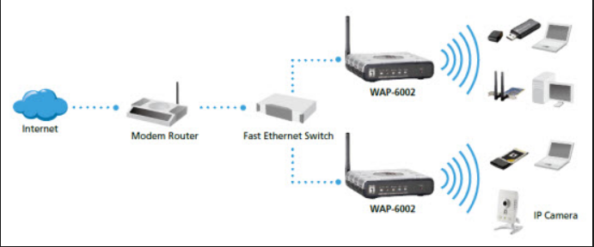
A

 | 3.1.1 | What is the function of the network interface indicated by A? | (2)
 | 3.1.2 | What is the hardware called that is indicated by B? | (1)
 | 3.1.3 | What communication medium is used between B and A? | (1)
 | 3.1.4 | Do you think it is necessary to use a router and a switch in the setup?  Motivate your answer. | (3)
 | 3.1.5 | a) What is the address of each computer or device connecting to the network called?  b) What rule must be followed when addresses are allocated to hardware devices? | (1)  (1)
3.2 | UTP (Unshielded twisted pair) cables are used to connect the switch and hardware device B
 | 3.2.1 | Name TWO physical restrictions of UTP cables besides the reach (distance) of the cable. | (2)
3.3 | Online services play a huge roll to reduce financial expenses when purchasing software.
 | 3.3.1 | Explain what SaaS (Software as a Service) is. | (1)
 | 3.3.2 | Name ONE advantage of SaaS. | (2)
 | 3.3.3 | Name TWO disadvantages of SaaS, besides the subscription fee. | (2)
3.4 | One of the online services provided by the companies is file synchronisation.
 | 3.4.1 | Name TWO advantages that the service offers the secretary of the business. | (2)
3.5 | The shop collects a lot of data every month that is stored in the different databases that are saved online.
 | 3.5.1 | Name TWO ways in which data mining can help the business to grow and improve. | (2)
3.6 | Scalability is one of the advantages of Cloud computing.  Explain what scalability is. |  | (2)

TOTAL SECTION C: 22

SECTION D: DATA AND INFORMATION MANAGEMENT

QUESTION 4
While you are busy to computerise all the data, you realise that the stock of the company is not monitored very effectively. You decide to help them to improve it.
4.1 |  | The following is a depiction of a relational database for the company:  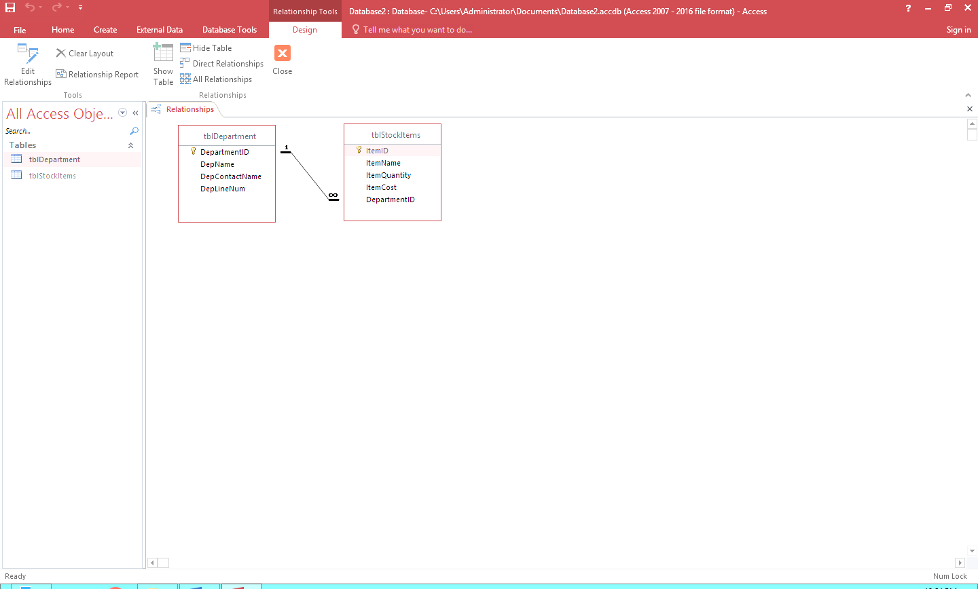  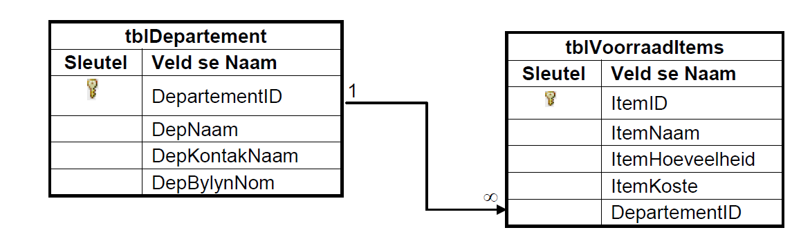
 | 4.1.1 | What is a relational database? | (1)
 | 4.1.2 | Name and explain the type of relationship between the two tables. | (2)
 | 4.1.3 | The data is normalised. What is the general purpose of normalisation? | (2)
 | 4.1.4 | a) The DepatementID field was chosen as the primary key for the tblDepartement table.  Explain why none of the other fields in this table would have been appropriate primary keys.  b) In the tblDepartement table the DepLineNum field is supposed to store the phone extension number of an employee, for example 0210. Give ONE reason why it would be incorrect to store this field as an Integer data type.  c) Give the correct data type for the DepLineNum field in the tblDepartement table. | (1)  (1)  (1)
4.2 |  | Database independence as well as database security was discussed during the compiling of the database.
 | 4.2.1 | Name THREE functions of a database administrator. | (3)
 | 4.2.2 | Why is it important to keep data independence in mind when tables are designed? | (1)
 | 4.2.3 | Give TWO examples of data independence. | (2)
 | 4.2.4 | Explain what is meant by data security. | (1)
 | 4.2.5 | Suggest TWO ways to ensure the security of the data. | (2)
4.3 |  | Give TWO advantages of installing a DBMS on the server. | (2)
4.4 |  | The company makes use of a distributed database system.
 | 4.4.1 | Compare a distributed database system with a database system that works on a single computer. Give TWO reasons why a distributed database system will need sophisticated security. | (2)
 | 4.4.2 | Give ONE advantage, from the user’s perspective, of working on a distributed database system compared to a database system on a single computer. | (2)
 | 4.4.3 | Briefly explain how sinchronisation takes place on a partition model of a distributed database system. | (2)

TOTAL SECTION D: 24

SECTION E: DATA AND INFORMATION MANAGEMENT

QUESTION 5
You offered your services to help the owner by writing and improving a few computer programs.

5.1 |  | Various mistakes can appear when a program is coded and executed.
 | 5.1.1 | The three common mistakes are sintax-, logic- and run-time errors.  Identify the type of error for each process in the table below. Write down only the answer next to the question number(5.1.1(a)–5.1.1(c)).  Tipe of error Error Error message  (a) No semicolon at the end of an instruction ‘Missing semicolon’  (b) The StockValue was incorrectly calculated as StockValue = quantity - itemPrice No error message  (c) A variable is created as an integer data type to store the number of items. When the program is executed, the user enters the word “seventeen” instead of 17 in the GUI component ‘Data-type mismatch’ | (3)
5.2 |  | The programmers made use of defensive programming and error handling in the programming code.
 | 5.2.1 | What is defensive progamming? | (1)
 | 5.2.2 | During a trial run of one of the programs that were developed, the program stopped working and the following error message was displayed:  ' execution halted – an overflow error occurred'
 |  | - Suggest TWO ways in which a programming code can be used to prevent a run-time-error such as this one from occuring. | (2)
5.3 |  | The following data structures can be used to manipulate and store data in programs:  • A two-dimensional array  • An array of type string  • A string  Choose the most appropriate structure in each of the following cases.
 | 5.3.1 | A list of names of 15 cities where the store’s franchises are. | (1)
 | 5.3.2 | The name of a store | (1)
 | 5.3.3 | Bookings for seats at a conference center. | (1)
 | 5.3.4 | When methods are written, paramaters are sometimes used to get values from the call statements.  Name TWO aspects that must be kept in mind when the arguments (actual parameters) for the call statement are provided. | (2)
5.4 |  | The company where you are involved will host a flea market to help them with the marketing of their business along with a few other small businesses.  The form below is designed to capture the data of a stall-object named objStall.  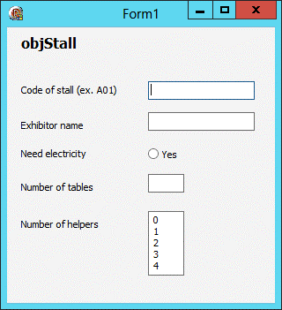
 | 5.4.1 | By using the form above, draw a UML(‘unified modelling language')-diagram for the objStall object class.  The diagram must include the following:  • All the attributes of this object according to the specifications of a UML diagram  • An accessor method for the ‘Code of stall’ attribute  • A mutator method for the ‘Need electricity’ attribute | (4)

5.5 |  | Study the code below and answer the questions.  begin  - objCardholder := TCardHolder.create(sCardHolder, sCellNumber, StrToInt(sLoyaltyPoints));  - sAccess := edtCode.Text;  - if objCardholder.isCorrect(sAccess) then begin  - showMessage('The access code is correct.');  - rTotalSpent := 0;  - rTotalHealth := 0;  - iVisits := 0;  - assignFile(myFile, 'DataJanuary2017.txt');  - reset(myFile);  - while not eof(myFile) do begin  - readln(myFile, sLineOne);  - readln(myFile, sLineTwo);  - readln(myFile, sLineThree);  - if sLineOne = sCardHolder then begin  - rTotalSpent := rTotalSpent + StrToFloat(sLineTwo);  - rTotalHealth := rTotalHealth + StrToFloat(sLineThree);  - inc(iVisits);  end; // end if  end; // end while  - closeFile(myFile);  end;
 | 5.5.1 | What do we call the method used in line 1? | (1)
 | 5.5.2 | Explain the code in line 1. | (1)
 | 5.5.3 | Explain the purpose of the following line of code:  assignFile(myFile, 'DataJanuary2019.txt'); | (2)
 | 5.5.4 | What is the purpose of the code in line 9? | (1)
 | 5.5.5 | Rewrite line 17 in a different manner. | (1)
 | 5.5.6 | Why is it important to initialise variables (for example in lines 5, 6 and 7)? | (1)

5.6 |  |  | The following algorithm is used in the program to add extra costs for clients that booked for a service but showed up late:  Step1 charge 0  Step2 amt 40  Step3 x time back  Step4 y time when vehicle enters  Step5 diff y – x  Step6 diff Round of difference to closest integer  Step7 if diff is less than 1  Step8 charge amt  else  Step9 loop from 1 to diff  begin loop  Step10 charge charge + amt*(value of loop counter)  Step11 display value of loop counter  Step12 display charge  end loop  Copy the following table trace table into your answer book and complete it to calculate the extra cost for a car that was supposed to be back by 8 o’clock but was only returned by 12 o’clock.  Step charge amt Diff Diff <1 Loop counter<= diff Output  1 0  2 40 |  |  | (8)
 |  |  | TOTAL SECTION E: 30

SECTION F: INTEGRATED SCENARIO

QUESTION 6

An information session will be held with all the drivers to make them aware of online security and new emerging technologies.
6.1 | Artificial Intelligence (AI) is increasingly being used by businesses. The screenshot below displays an example if Discovery’s web page (www.discovery.co.za) is visited.
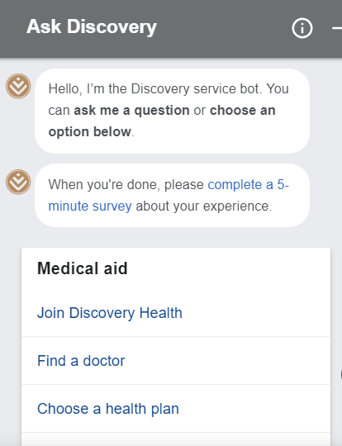


B Window appears

A Click on
the icon

 | 6.1.1 | Name TWO advantages of the use of a virtual assistant (chatbot) in a business. | (2)
 | 6.1.2 | Name ONE disadvantage of a virtual assistant in a business. | (1)
 | 6.1.3 | What is the name of the programming language that is used to extract data from a database? | (1)

6.2 | The photo below is an example of an RFID capsule that is used by the business and placed in their mobile devices.
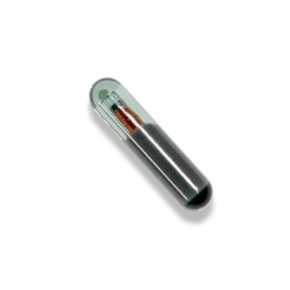
RFID - capsule
 | 6.2.1 | Name the TWO parts out of which a RFID capsule consists. | (2)
 | 6.2.2 | Name TWO types of information that could possibly be saved on the chip. | (2)
 | 6.2.3 | Explain how the passive chip of the RFID capsule works. | (2)
6.3 | Businesses are exposed to various online threats. You advice the business to employ a white hat hacker.
 | 6.3.1 | What is the job of a white hat hacker in a business? | (1)
 | 6.3.2 | Explain the following computer threats:  - Computer worm  - Trojan | (2)  (2)
 | 6.3.3 | One of the businesses lost a case in court because they send out too many advertisements.  - What is the crime described here known as?  - Name TWO ways in which the business gets hold of the email adresses of people that are not clients of the business. | (1)  (2)
6.4 | Online security is important for every business that has a website when online transactions are performed.
 | 6.4.1 | Explain what SSL is. | (2)

 | 6.4.2 | 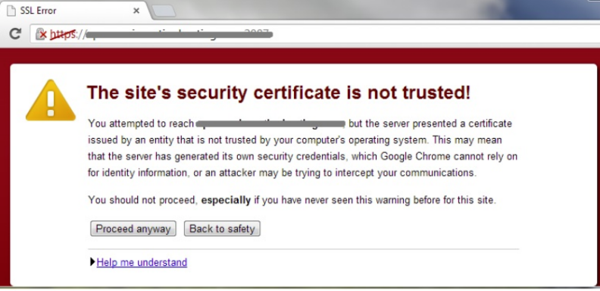  Study the following screenshot of a website error message and then answer the questions that follow.
 |  | - What is a digital certificate?  - Name TWO types of information found on the certificate.  - Name one characteristic from the screenshot of the web address that will change if the website is safe. |  |  | (2)  (2)  (1)
6.5 | An intranet is necessary so that workers in remote locations can get access to the company’s information.
 | 6.5.1 | What is an intranet? |  |  | (1)
 | 6.5.2 | Name the security precaution that must be in place for users to get access to parts  of the intranet. |  |  | (1)
6.6 | Companies must regularly upgrade technology, and get rid of all the old technologies/devices.
 | 6.6.1 | Name ONE way in which companies can reduce their impact on the environment  when they do upgrades. |  |  | (1)
 | 6.6.2 | Name one setting you can change on the printer to use less paper. |  |  | (1)
6.7 | Employees must attend annual workshops to stay up to date with work content.
 | 6.7.1 | Explain the concept of a webinar. |  |  | (1)
 | 6.7.2 | Name ONE advantage of a webinar. |  |  | (1)
6.8 | The design of websites is very important when it comes to attracting online customers.
 | 6.8.1 | What is the difference between a dynamic and a static website? |  |  | (2)
 | 6.8.2 | Which technique does web designers employ to place websites higher on the list of search results? |  |  | (1)
 |  |  |  | TOTAL SECTION F:33
 |  |  |  | GRAND TOTAL: |  | 150

