Naam van leerling/Name of learner:………………………………………………..

November/November
Graad/Grade 8 Punte/Marks: 100
Wiskunde Tweede Vraestel Tyd/Time: 2 ure/hours
Mathematics Second Paper
Eksaminator/Examinator: Moderator:

INSTRUKSIES AAN KANDIDATE

INSTRUCTIONS TO CANDIDATES

- Hierdie vraestel bestaan uit DRIE vrae. Beantwoord AL DRIE die vrae.
This question paper consists of THREE questions. Answer ALL THREE questions.
- Nommer presies soos op die vraestel.
Number the answers exactly as on the paper.
- Begin elke vraag op ‘n nuwe bladsy en trek ‘n lyn na elke vraag .
Laat ‘n spasie na elke nommer.
Start each question on a new page and draw a line at the end of each
question. Leave a space between each number.
- Jy mag ‘n goedgekeurde sakrekenaar gebruik, tensy anders vermeld
You may use an approved calculator, unless stated otherwise.
6 Wys al jou bewerkings en dit is tot jou voordeel om netjies te werk
Show all your calculations and it is in your own interest to work neatly.
7 Rond AL die finale antwoorde tot TWEE desimale plekke af, tensy anders aangedui.
Round off ALL the final answers off to TWO decimal places, unless stated otherwise.
8 Dui meeteenhede aan waar van toepassing.
Indicate units of measurement, where applicable.
9. Sterkte!
Good luck!

VRAAG QUESTION 1

1.1 | Die histogram hieronder toon die aantal atlete in spesifieke ouderdomsgroepe wat die Twee Oseane Half maraton in Maart 2013 gehardloop het. Die oudste atleet was 79 jaar.  The histogram below shows the number of athletes in specific age groups who participated in the Two Oceans Half Marathon in March 2013. The oldest runner was 79 years.  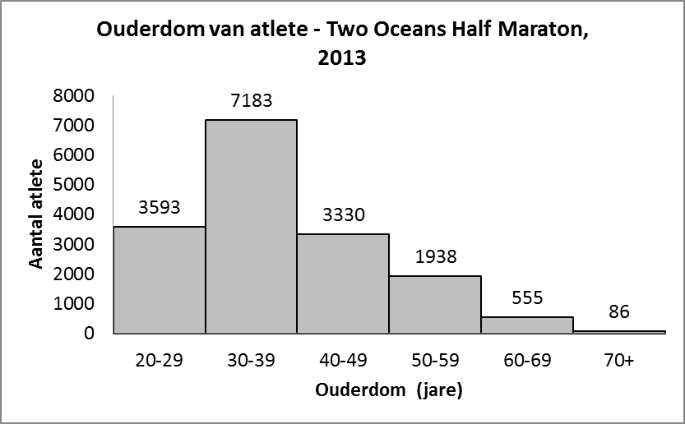
 | 1.1.1 |  |  | Hoeveel atlete onder 30 jaar het die Twee Oseane Half maraton gehardloop? How many athletes under 30 years participated in the Two Oceans Half marathon? |  | (1)
 | 1.1.2 |  |  | In watter ouderdoms groep was die meeste atlete wat die Twee Oseane Half maraton gehardloop het?  In what age group did the most athletes participate in the Two Oceans Half Marathon? |  | (1)
 | 1.1.3 |  |  | Hoeveel atlete in totaal het die Twee Oseane Half maraton gehardloop?  How many athletes in total participated in the Two Oceans Half marathon? |  | (2)
 | 1.1.4 |  |  | Vergelyk die aantal atlete jonger as 50 met die wat 50 en ouer was. Beskryf jou waarneming en gee ‘n moontlike rede vir wat jy opmerk.  Compare the number of athletes younger than 50 to those 50 and older. Describe your observations and give a possible reason for your observations. |  | (2)
1.2 Die data stel die ouderdomme voor van 15 vroulike atlete.
This data set represent the ages of 15 female marathon athletes

50 34 48 23 49 32 36 37 41 29 42 43 37 38 41

 | 1.2.1  1.2.2  1.2.3 |  |  | Organiseer die data met behulp van ‘n stingel-en-blaar diagram  Organise the data with a stem-and-leaf diagram (4)  Skryf die omvang neer  Write down the range (3)  Wat is die modale ouderdom?  What is the modal age? (2)
 | 1.2.4  1.2.5 |  |  | Bereken die gemiddelde ouderdom korrek tot TWEE desimale plekke Calculate the mean of the ages correct to TWO decimal places. (4)  Bepaal die mediaan van die ouderdomme  Determine the median age (2)
1.2.6 Kopieër en voltooi die frekwensie tabel met hierdie ouderdomsgroepe
Copy and complete the frequency table with this age groups

Ouderdomsgroepe  Age groups | Telmerke  Tally | Frekwensie  Frequency
20 – 29
30 – 39
40 – 49
50 – 59

(4)
[25]
VRAAG 2
QUESTION 2

2.1 Voltooi: Complete:

2.1.1 Die supplement van 35º is ………………………
The supplement of 35º is …………………………..
2.1.2 70º is die …………… van 20º
70º is the ………………………..of 20º
2.1.3 ‘n Hoek van 360º word ‘n ……………………..genoem
An angle of 360º is called a …………………………
2.1.4 ‘n Driehoek met 3 gelyke sye word ‘n ……………..genoem
A triangle with three equal sides is called …………………….
2.1.5 In ‘n reghoekige gelykbenige driehoek is die grootte van die
hoeke ……º, ……º en …….º
In a right-angled isosceles triangle the sizes of the angles are
……º, ……..º and …….º
2.1.6 Regoorstaande hoeke is …………………
Vertically opposite angles are ……………..
(8)
2.2  2.3 | Kyk na die tekening en identifiseer die volgende pare hoeke:  Look at the drawing and identify the following pairs of angles:  5  1 2 6  3 7  4 8  2.2.1. 1 en / and 2  2.2.2 5 en / and 7  2.2.3 3 en / and 8  2.2.4 3 en / and 6  2.2.5 4 en / and 8 (5)  Vind die waardes van x en y in elk van die volgende figure met REDES  Find the values of x and y in each of the following figures with REASONS  2.3.1  40º y  x  (4)  2.3.2
y

62º x
(4)

2.3.3 A B
y
40º

C x D
E (5)

2.4 In hierdie skets is, AB // EC en AD // BC, ∠ABG = 63º en ∠AGB = 56º
Bereken die grootte van a, b, c, d en e met REDES
In this sketch, AB // EC and AD // BC, ∠ ABG = 63 ° and ∠ AGB = 56 °.
Determine the size of a, b, c, d and e with REASONS

A B
a 63º
d
56º
G

E b c C
e D
F (10)

2.5 Los op vir $x$ in die driehoek hieronder met redes
Solve for x in the triangle below with reasons

x

4x
2x + 40º

(4)
[40]
VRAAG 3
QUESTION 3

3.1 |  | Bereken hoeveel is AB langer as DE  Determine how much AB is langer than DE
3.2 |  | A  25 E  25  B D  7 C 15 (7)  Bereken die oppervlakte van MNRS as NS = 17 cm  Determine the area of MNRS if NS = 17 cm M  11  N 17 S  9  R  (6)
3.3.1 |  | Bereken die oppervlakte van ‘n sirkel met middellyn d = 14 cm en gebruik π = $\frac{22}{7}$  Determine the area of the circle with diameter d=14, and use π =$\frac{22}{7}$ (4)
3.3.2 |  | Bereken die omtrek van ‘n sirkel met radius r = 8 cm en gebruik π = 3.14  Determine the circumference of the circle with radius r = 8 cm and use π = 3.14 (4)
3.4 |  | Bereken die omtrek van die volgende atletiekbaan (korrek tot 2 desimale plekke)  Determine the perimeter of the following athletic track.(correct to two decimal places)
102 m

60 m

3.5 |  | (6)
36

54

72

3.5.1  3.5.2 |  | Bereken die buite-oppervlakte van die figuur as lengte = 72 cm, breedte = 54 cm  en hoogte = 36 cm  Determine the surface area of this figure if the length = 72 cm, breadth = 54 cm  and height = 36 cm (5)  Bepaal die volume van die figuur  Determine the volume of this figure. (3)  [35]  TOTAAL: 100

